 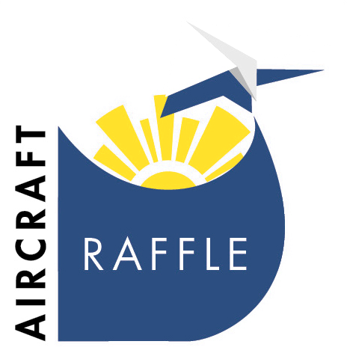

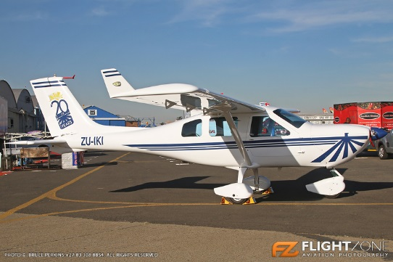

**Aircraft Raffle and Draw**

**Set Up**

**Tuesday 28th**

3 pm onwards – Danie and his team from Jaibru Aviation set up

4 pm Brand Evolution to set up tables and stanchions around aircraft

**Wednesday 29th and Thursday 30th**

- Reach for a dream representative on duty from 8.30 - 3pm .

**Friday 1 December**

10.30 am guest arrival for live draw –auditors to be present

11 am live draw to take place mc’d by Jolene Martin ( ex Lotto Powerball host) who will do the draw aw and phone the winner

11.30 Media interviews and picture oppurtunties /snacks to be served to guests.

12 pm strilke to commence Aircraft to be taken away to Jaibru premises for winner to collect.