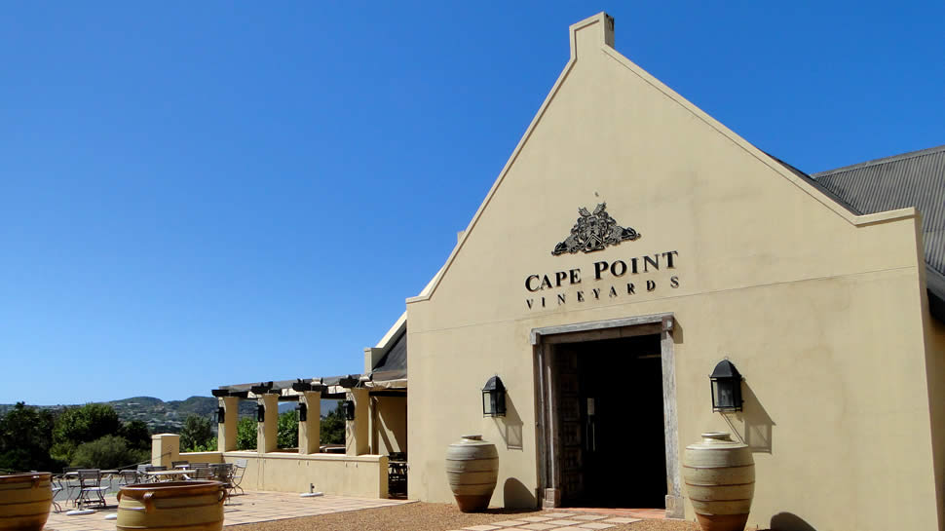

Join us for a cellar Tour and Wine Tasting at our local Winery Cape   
Point Vineyards

May 23rd at 11h00

Cost is R165.00 which includes 5 x 50ml tastings and return transport from Muizenberg.

**Transport will depart from Reception at 10h00.**

There are only 12 spaces available. Require a minimum of 5 residents for tour to take place.

Menu Option if you would like to nibble on something whilst tasting which is for your own cost:

Cheese Board at R150.00 - this will need to be pre-ordered so please advise reception by 10th May and this will be a settle direct with the Winery on the day

**RSVP and pay at Reception by no later than 17th May 2019**

