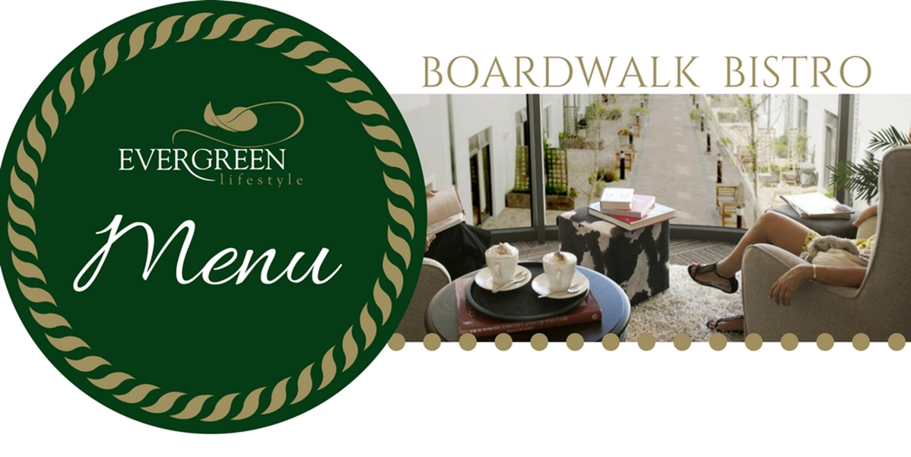

MAY 2019

**Kindly book your meals as follows:**

Lunch bookings by 16h30 for the following day

Friday Fish & Chips by 11h00 on the day

Saturday & Sunday bookings by 16h30 on Fridays.

**Meal prices:**

|  |  |
| --- | --- |
| Starter | R 12.00 |
| Standard Main Course | R 48.00 |
| Premium Main Course | R 61.00 |
| Sunday Main Course | R 80.00 |
| Dessert | R 16.00 |
| Take Away Charge | R 6.00 |

Yours in Service



|  |  |  |  |  |  |  |
| --- | --- | --- | --- | --- | --- | --- |
|  | **STARTER** | | **MAIN OPTION 1** | | **MAIN OPTION 2** | **DESSERT** |
| WEDNESDAY  1 MAY | CREAMY BUTTERNUT SOUP SERVED WITH ROLL & BUTTER | | CHICKEN & MUSHROOM PIE SERVED WITH PARSLEY POTATOES & SEASONAL VEGETABLES | | LAMBS LIVER & ONION GRAVY, MASHED POTATOES & SEASONAL VEGETABLES | POACHED PEARS & CUSTARD |
| THURSDAY  2 MAY | BRUSCHETTA SERVED WITH SALMON & CREAM CHEESE | | COTTAGE PIE SERVED WITH SEASONAL VEGETABLES | | SWEET & SOUR TEMPURA PORK, PARSLEY RICE & SEASONAL VEGETABLES | COFFEE CHOCOLATE MOUSE |
| FRIDAY  3 MAY | VEGETABLE SAMOOSAS | | HONEY & MUSTARD BROCOLLI CHICKEN BAKE & ROAST VEGETABLES | | **PREMIUM:**  FRIED FISH WITH TARTAR SAUCE, CHIPS & SALAD OF THE DAY | APRICOT BREAD & BUTTER PUDDING |
| SATURDAY  4 MAY | FETA & SPINACH BASKETS | | SPAGHETTI BOLOGNAISE SERVED WITH SALAD OF THE DAY | | PHYLLO ROAST VEGETABLE & BACON TART, POTATO WEDGES & SALAD OF THE DAY | ECLAIRS |
| SUNDAY  5 MAY | SPICY TOMATO SOUP SERVED WITH BREAD ROLL & BUTTER | | ROAST BEEF, YORKSHIRE PUDDING, ROAST POTATOES & SEAONAL VEGETABLES | | APRICOT ROAST CHICKEN, ROAST POTATOES & SEASONAL VEGETABLES | STICKY TOFFEE PUDDING & CUSTARD |
|  | | | | | | |
|  | **STARTER** | | **MAIN OPTION 1** | | **MAIN OPTION 2** | **DESSERT** |
| MONDAY  6 MAY | CAPRESE KEBAB | | FISHERMANS PIE SERVED WITH SEASONAL VEGETABLES | | SPINACH & FETA CHICKEN BAKE SERVED WITH LENTIL RICE & SEASONAL VEGETABLES | GRILLED GUAVAS SERVED WITH CUSTARD |
| TUESDAY  7 MAY | CHICKEN PETITE CREPES | | CHICKEN, BUTTERNUT & FETA LASAGNE SERVED WITH SALAD OF THE DAY | | **PREMIUM:**  CRUMBED CALAMARI & TARTAR SAUCE SERVED WITH CHIPS & SALAD OF THE DAY | VOLCANO CHOCOLATE PUDDING |
| WEDNESDAY  8 MAY | CRUMBED MUSHROOMS | | HOMEMADE CORNISH & PIE, GRAVY, MASHED POTATO & SEASONAL VEGETABLES | | BACON, FETA & MUSHROOM QUICHE, POTATO WEDGES SERVED WITH A SALAD OF THE DAY | APPLE CRUMBLE & CREAM |
| THURSDAY  9 MAY | HOMEMADE VEGETABLE SOUP SERVED WITH BREADROLL & BUTTER | | CREAMY SPINACH & FETA PANCAKES SERVED WITH POTATO WEDGES & SALAD OF THE DAY | | CHICKEN STIRFRY SERVED ON EGG NOODLES & SEASONAL VEGETABLES | BUTTERSCOTCH & GINGER TART |
| FRIDAY  10 MAY | ROASTED TOMATO & FETA TARTLET | | BEEF LASAGNE SERVED WITH SALAD OF THE DA | | **PREMIUM:**  FRIED FISH WITH TARTAR SAUCE, CHIPS & SALAD OF THE DAY | ICE CREAM & CHOCOLATE SAUCE |
| SATURDAY  11 MAY | ZUCCINI FRITTERS | | SPINACH & SALMON PASTA SERVED WITH SEASONAL VEGETABLES | | CHICKEN STRIPS, CHEESE SAUCE, POTATO WEDGES & SEASONAL VEGETABLES | MILKTART |
| SUNDAY  12 MAY | CAMEMBERT & ONION MARMELADE PARCEL | | **MOTHER’S DAY LUNCH**  ROAST PORK NECK SERVED WITH A BERRY JUS, ROAST POTATOES & SEASONAL VEGETABLES | | HONEY & MUSTARD ROAST CHICKEN , ROAST POTATOES & SEASONAL VEGETABLES | MALVA PUDDING & CUSTARD |
|  | | | | | | |
|  | **STARTER** | **MAIN OPTION 1** | | **MAIN OPTION 2** | | **DESSERT** |
| MONDAY  13 MAY | HOMEMADE BEAN SOUP SERVED WITH BREAD ROLL & BUTTER | TOMATO CHICKEN SERVED, MASHED POTATO & SEASONAL VEGETABLES | | COTTAGE PIE, GRAVY SERVED WITH MASHED POTATOES & SEASONAL VEGETABLES | | LEMON BAKED PUDDING & CUSTARD |
| TUESDAY  14 MAY | ONION RINGS SERVED WITH A TARTAR SAUCE | BEEF BOBOTIE SERVED WITH YELLOW RICE & SEASONAL VEGETABLES | | PORK SAUSAGES & GRAVY, MASHED POTATOES & SEASONAL VEGETABLES | | JELLY & CUSTARD |
| WEDNESDAY  15 MAY | PUMPKIN FRITTERS & CARAMEL SAUCE | PORK & APPLE PIE, GRAVY SERVED WITH BABY POTATOES & SEASONAL VEGETABLES | | FISHCAKES ,TOMATO, ONION RELISH, MASHED POTATO & SEASONAL VEGETABLES | | CHURRO CUP FILLED WITH ICE CREAM |
| THURSDAY  16 MAY | POTATO & LEEK SOUP SERVED WITH BREAD ROLL & BUTTER | CHICKEN, BROCCOLI & FETA BAKE, RICE & SEASONAL VEGETABLES | | SAVOURY MINCE PANCAKES, POTATO WEDGES & SEASONAL VEGETABLES | | CHEF’S TART |
| FRIDAY  17 MAY | THREE CHEESE PARCEL | GREENBEAN BREDIE, RICE & SEASONAL VEGETABLES | | **PREMIUM:**  FRIED FISH WITH TARTAR SAUCE, CHIPS & SALAD OF THE DAY | | CHOCOLATE MOUSSE |
| SATURDAY  18 MAY | AUBERGINE TOPPED WITH TOMATO & MOZARELLA | ROAST CHICKEN, SPINACH & FETA QUICHE, CHIPS & SALAD OF THE DAY | | BOEREWORS ROLLS WITH TOMATO RELISH, CHIPS & SALAD OF THE DAY | | CHELSEA BUN |
| SUNDAY  19 MAY | CREAMY BUTTERNUT PUDDING, BREAD ROLL & BUTTER | REDWINE MARINATED ROAST BEEF & GRAVY, ROAST POTATOES & SEASONAL VEGETABLES | | CHUTNEY ROAST CHICKEN, ROAST POTATOES & SEASONAL VEGETABLES | | BAKED ORANGE PUDDING & CUSTARD |
|  | **STARTER** | **MAIN OPTION 1** | | **MAIN OPTION 2** | | **DESSERT** |
| MONDAY  20 MAY | BASIL & MOZARELLA BRUSCHETTA | BUTTER CHICKEN & BASMATI RICE SERVED WITH SEASONAL VEGETABLES | | BEEF SAUSAGES, GRAVY SERVED WITH MASHED POTATOES & SEASONAL VEGETABLES | | GRILLED PEACHES & CREAM |
| TUESDAY  21 MAY | POTATO FRITTERS WITH A SWEET TARTAR DRESSING | CHICKEN LIVER & MUSHROOM LASAGNE SERVED WITH GREEK SALAD | | TOMATO BREDIE, LENTIL RICE & SEASONAL VEGETABLES | | PEPPERMINT TART |
| WEDNESDAY  22 MAY | MINESTRONE SOUP SERVED WITH BREAD ROLL & BUTTER | CHICKEN & LEEK PIE, GRAVY & PARSLEY POTATOES WITH SEASON VEGETABLES | | LAMBS LIVER & ONION GRAVY, MASHED POTATO & SEASONAL VEGETABLES | | APRICOT SAGO PUDDING & CUSTARD |
| THURSDAY  23 MAY | SALMON BASKET | LENTIL & BEEF BOBOTIE SERVED WITH SEASONAL VEGETABLES | | CHICKEN SCHNITZEL, MUSHROOM SAUCE, POTATO WEDGES & SEASONAL VEGETABLES | | LEMON CHEESE CAKE |
| FRIDAY  24 MAY | BAKED STUFFED TOMATO SERVED WITH A PESTO DRESSING | BACON, RED ONION & FETA QUICHE, CHIPS & SALAD OF THE DAY | | **PREMIUM:**  FRIED FISH WITH TARTAR SAUCE, CHIPS & SALAD OF THE DAY | | CUSTARD CUPS |
| SATURDAY  25 MAY | BROCOLLI SOUP SERVED WITH BREAD ROLL & BUTTER | CHICKEN & MUSHROOM PASTA BAKE SERVED WITH SALAD OF THE DAY | | BEEF BURGERS TOPPED WITH CARAMELIZED ONIONS , CHIPS & SALAD OF THE DAY | | ICE CREAM & FRUITY SAUCE |
| SUNDAY  26 MAY | SPRINGROLLS SERVED WITH A SWEET MAYO DRESSING | APRICOT GLAZED GAMMON SERVED WITH ROAST POTATOES & SEASONAL VEGETABLES | | LEMON & HERB ROAST CHICKEN, ROAST POTATOES & SEASONAL VEGETABLES | | DATE PUDDING & CREAM |

|  |  |  |  |  |  |
| --- | --- | --- | --- | --- | --- |
|  | | **STARTER** | **MAIN OPTION 1** | **MAIN OPTION 2** | **DESSERT** |
| MONDAY  27 MAY | ROASTED VEGETABLE KEBAB | | BEEF LASAGNE SERVED WITH SALAD OF THE DAY | **PREMIUM**  GREEKSTYLE HAKE SERVED WITH SAVOURY RICE & SALAD OF THE DAY | RICE PUDDING SERVED WITH CUSTARD |
| TUESDAY  28 MAY | CREAMY MUSHROOM SOUP SERVED WITH BREAD ROLL & BUTTER | | SWEET MUSTARD HAWAIIAN CHICKEN BAKE SERVED WITH PARSLEY RICE & SEASONAL VEGETABLES | PORK SCHNITZEL, MUSHROOM SAUCE SERVED WITH PARSLEY POTATOES & SEASONAL VEGETABLES | PASTRY APPLE BASKETS |
| WEDNESDAY  29 MAY | BROCOLLI & FETA PETITE CREPES | | STEAK & KIDNEY PIE SERVED, SWEET POTATO MASH & SEASONAL VEGETABLES | SWEET & SOUR CHICKEN SERVED WITH FETTUCINE & SEASONAL VEGETABLES | BARONE MOUSSE |
| THURSDAY  30 MAY | CAPRESE SALAD | | BEEF MEATBALLS ON SPAGHETTI WITH TOMATO & ONION RELISH SERVED WITH SEASONAL VEGETABLES | BBQ CHICKEN KEBABS SERVED WITH BABY POTATOES & SEASONAL VEGETABLES | ICE CREAM & MINTY CHOCOLATE SAUCE |
| FRIDAY  31 MAY | LENTIL SOUP SERVED WITH BREAD ROLL & BUTTER | | CHICKEN CURRY SERVED WITH SAMBALS, RICE & SEASONAL VEGETABLES | **MONTHLY MADNESS R50:**  FRIED FISH WITH TARTAR SAUCE, CHIPS & SALAD OF THE DAY | PEACH CRUMBLE & CUSTARD |