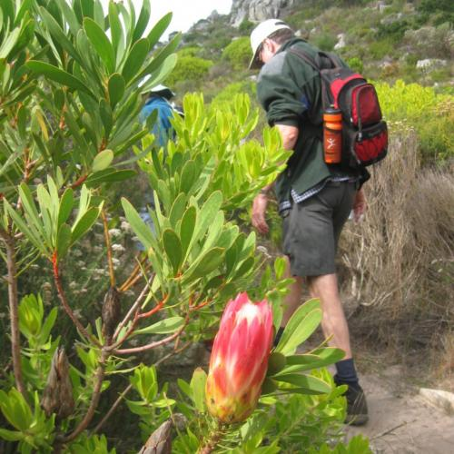

Walking & Hiking Group

The first Walk will be on 24 February 2018

Time 07H00

Walk – from Muizenberg to Kalk Bay + back with Mr de Wet ext 138

Anyone interested can give their name in at reception