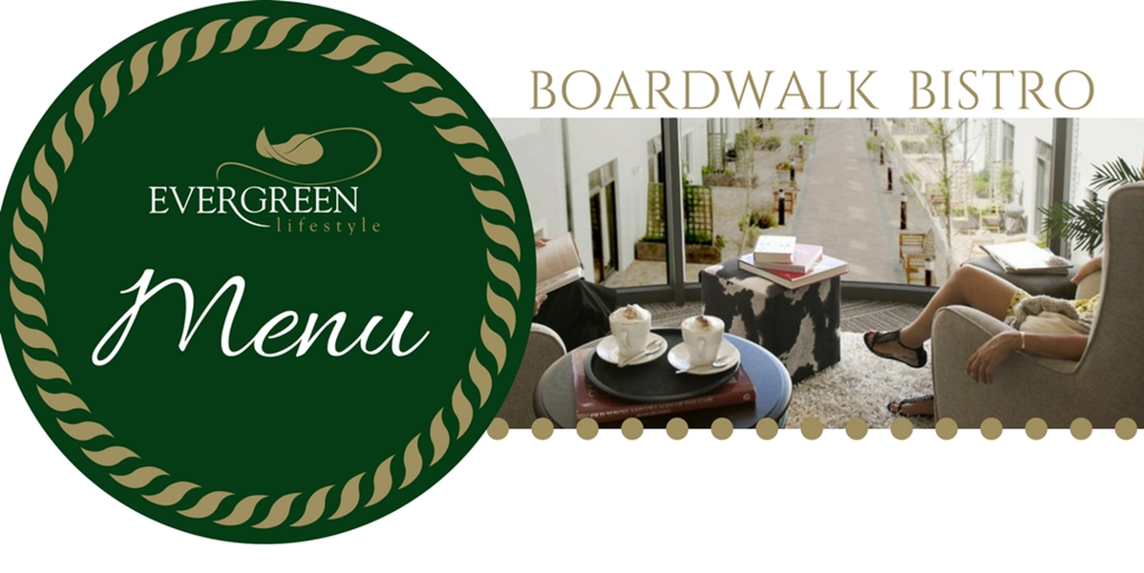

DECEMBER 2018

**Kindly book your meals as follow:**

Lunch bookings by 16h30 for the following day

Friday Fish & Chips by 11h00 on the day

Saturday & Sunday bookings by 16h30 on Fridays.

**Meal prices:**

|  |  |
| --- | --- |
| Starter | R 12.00 |
| Standard Main Course | R 48.00 |
| Premium Main Course | R 61.00 |
| Sunday Main Course | R 80.00 |
| Dessert | R 16.00 |
| Take Away Charge | R 6.00 |



Yours in Service



|  |  |  |  |  |
| --- | --- | --- | --- | --- |
|  | **STARTER** | **MAIN OPTION 1** | **MAIN OPTION 2** | **DESSERT** |
| **SATURDAY**  **1 DECEMBER** | BROCCOLI & CHEDDAR FRITTER | BACON CARBONARA PASTA SERVED WITH SALAD OF THE DAY | BEEF SAUSAGES & GRAVY SERVED WITH MASHED POTATOES & SEASONAL VEGETABLES | ICE CREAM & CHOCOLATE SAUCE |
| **SUNDAY**  **2 DECEMBER** | MUSHROOM BALLS WITH A SWEET CHILLY SAUCE | ROAST PORK LEG, APPLE SAUCE, ROAST POTATOES & SEASONAL VEGETABLES | SWEET MUSTARD ROAST CHICKEN, ROAST POTATOES & SEASONAL VEGETABLES | CRÈME BRULEE |
|  | | | | |
| **C:\Users\RuanH\Downloads\BURGER.jpg** | | | | |
|  | **STARTER** | **MAIN OPTION 1** | **MAIN OPTION 2** | **DESSERT** |
| **MONDAY**  **3 DECEMBER** | SPINACH & FETA PHYLLOW BASKETS | GREEKSTYLE CHICKEN & SPINACH SERVED ON EGG NOODLES & SALAD OF THE DAY | FISHCAKES WITH TOMATO RELISH , MASHED POTATOES & SALAD OF THE DAY | GRILLED PEACHES & ICE CREAM |
| **TUESDAY**  **4 DECEMBER** | CREAMY BUTTERNUT SOUP SERVED WITH A ROLL & BUTTER | FISHERMANS PIE SERVED WITH SEASONAL VEGETABLES | BOBOTIE PANCAKES WITH PARSLEY POTATOES SERVED WITH SALAD OF THE DAY | KOEKSISTERS |
| **WEDNESDAY**  **5 DECEMBER** | CREAMY SALMON BRUSCHETTA | LAMBS LIVER WITH ONION GRAVY & MASHED POTATO & SALAD OF THE DAY | CHICKEN & VEGETABLE PIE SERVED WITH PARSLEY RICE & SALAD OF THE DAY | CHOCOLATE MOUSSE |
| **THURSDAY**  **6 DECEMBER** | BEETROOT & FETA STACK | BEEF MEATBALLS WITH A TOMATO RELISH SERVED ON SPAGETTI & SALAD OF THE DAY | SUMMERSTYLE SALSA PORK CHOP SERVED WITH SWEET POTATO WEDGES & SALAD OF THE DAY | FRUIT KEBAB & KIWI DRESSING |
| **FRIDAY**  **7 DECEMBER** | BAKED AUBERGINE WITH TOMATO & MOZARELLA | BACON & BROCOLLI QUICHE, CHIPS & SALAD OF THE DAY | **PREMIUM:**  FRIED FISH WITH TARTAR SAUCE, CHIPS & SALAD OF THE DAY | CHOCOLATE KISSES |
| **SATURDAY**  **8 DECEMBER** | SWEET CORN FRITTERS | CREAMY SALMON & SPINACH PASTA & SALAD OF THE DAY | BEEF SAUSAGES, MASHED POTATOES & SALAD OF THE DAY | MILKTART |
| **SUNDAY**  **9 DECEMBER** | SESAME SALMON CUCUMBER STACK | ROAST BEEF & YORKSHIRE PUDDING , ROAST POTATOES & SEASONAL VEGETABLES | CHUTNEY CHICKEN, ROAST POTATOES & SEASONAL VEGETABLES | PEACH CRUMBLE & CUSTARD |

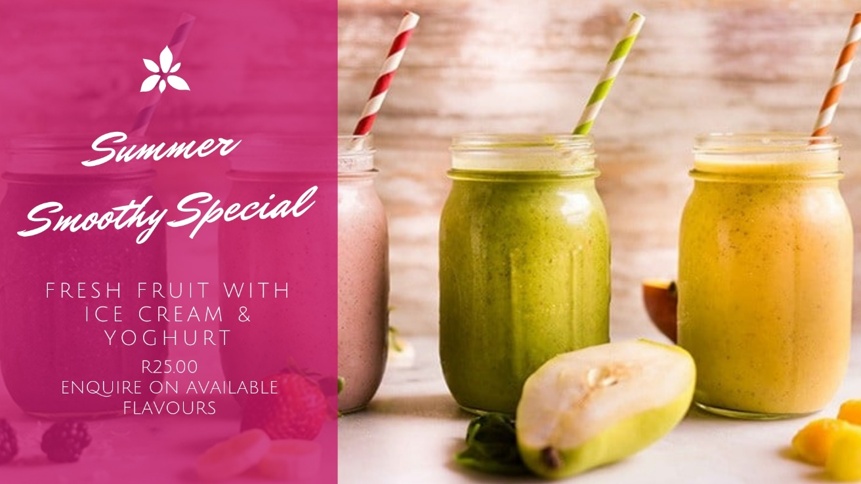

|  |  |  |  |  |
| --- | --- | --- | --- | --- |
|  | **STARTER** | **MAIN OPTION 1** | **MAIN OPTION 2** | **DESSERT** |
| **MONDAY**  **10 DECEMBER** | ROAST VEGETABLE SALAD WITH A GREEK DRESSING | BUTTERNUT COTTAGE PIE SERVED WITH SEASONAL VEGETABLES | CRUMBED CHICKEN STRIPS WITH A MUSHROOM SAUCE, CHIPS & SALAD OF THE DAY | BAKED SAGO PUDDING & CUSTARD |
| **TUESDAY**  **11 DECEMBER** | CAPRESE SALAD | SPINACH & FETA PANCAKES, POTATO WEDGES & SALAD OF THE DAY | **PREMIUM**  CRUMBED CALAMARI WITH CHIPS & SALAD OF THE DAY | ORANGE PUDDING WITH CUSTARD |
| **WEDNESDAY**  **12 DECEMBER** | CREAMY MUSHROOM SOUP SERVED WITH BREAD ROLL & BUTTER | CHICKEN STIRFRY SERVED ON EGG NOODLES SERVED WITH SEASONAL VEGETABLES | STEAK & KIDNEY PIE, SERVED WITH SWEET POTATO WEDGES & SEASONAL VEGETABLES | BUTTERSCOTCH MOUSSE |
| **THURSDAY**  **13 DECEMBER** | BACON & MOZARELLA BRUSCHETTA | SALMON & AVO GREEKSTYLE SALAD SERVED WITH HOMEMADE BREAD | SWEET & SOUR PORK, PARSLEY RICE & SEASONAL VEGETABLES | PANNACOTTA WITH BERRY SAUCE |
| **FRIDAY**  **14 DECEMBER** | CRUMBED MUSHROOMS SERVED WITH TARTAR SAUCE | BUTTERNUT, SPINACH & FETA PHYLLOW TART, CHIPS & SALAD OF THE DAY | **PREMIUM:**  FRIED FISH WITH TARTAR SAUCE, CHIPS & SALAD OF THE DAY | ICE CREAM WITH BERRY SAUCE |
| **SATURDAY**  **15 DECEMBER** | CREAMY BROCCOLI & FETA PANCAKES | LENTIL BOBOTIE & SWEET POTATO MASH SERVED WITH SALAD OF THE DAY | BROCOLI, CHICKEN & FETA BAKE SERVED WITH PARSLEY RICE & SALAD OF THE DAY | FRUIT DANISHES |
| **SUNDAY**  **16 DECEMBER** | SAMOOSAS & SWEET CHILLI SAUCE | APRICOT GLAZED GAMMON, ROAST POTATOES & SEASONAL VEGETABLES | ROAST APRICOT CHICKEN, ROAST POTATOES & SEASONAL VEGETABLES | DATE PUDDING WITH CREAM |

|  |  |  |  |  |
| --- | --- | --- | --- | --- |
|  | **STARTER** | **MAIN OPTION 1** | **MAIN OPTION 2** | **DESSERT** |
| **MONDAY**  **17 DECEMBER** | BUTTERNUT & RAISIN TOPPED SALAD | BEEF LASAGNE SERVED WITH CHEF’S SALAD | CHICKEN SCHNITZEL WITH A MUSHROOM SAUCE, POTATO WEDGES & SEASONAL VEGETABLES | GRILLED CINNAMON GUAVAS & CUSTARD |
| **TUESDAY**  **18 DECEMBER** | VEGETABLE SOUP SERVED WITH BREAD ROLL & BUTTER | TOMATO CHICKEN WITH MASHED POTATOES SERVED WITH SALAD OF THE DAY | **PREMIUM**  PORTUGUESE FISH WITH SAVOURY RICE & SALAD OF THE DAY | FRIED BANANA & ICE CREAM |
| **WEDNESDAY**  **19 DECEMBER** | ROAST VEGETABLE SALAD | LAMBS LIVER WITH ONION GRAVY & MASHED POTATO & SALAD OF THE DAY | PORK & APPLE PIE WITH GRAVY, PARSLEY POTATOES & SEASONAL VEGETABLES | LEMON TART |
| **THURSDAY**  **20 DECEMBER** | PUMPKIN FRITTERS | ROAST VEGETABLE & GREEK PESTO CHICKEN SALAD SERVED ON COUSCOUS | FISHCAKES WITH A TOMATO & ONION RELISH, MASHED POTATOES & SEASONAL VEGETABLES | CINNAMON PANCAKES SERVED WITH ICE CREAM |
| **FRIDAY**  **21 DECEMBER** | CAPRESE KEBAB | CHICKEN, BUTTERNUT & FETA LASAGNE SERVED WITH SALAD OF THE DAY | **PREMIUM:**  FRIED FISH WITH TARTAR SAUCE, CHIPS & SALAD OF THE DAY | ICE CREAM & CHOCOLATE SAUCE |
| **SATURDAY**  **22 DECEMBER** | SPICY CHICKEN LIVER BRUSCHETTA | SPAGETTI BOLOGNAISE SERVED WITH SALAD OF THE DAY | PORK SCHNITZEL WITH CHEESE SAUCE, SWEET POTATO & SALAD OF THE DAY | STRAWBERRY MOUSSE |
| **SUNDAY**  **23 DECEMBER** | PHYLLOW BASKET WITH CREAMY SALMON | REDWINE MARINATED BEEF SERVED WITH GRAVY, ROAST POTATOES & SEASONAL VEGETABLES | GREEKSTYLE ROAST CHICKEN WITH ROAST POTATOES & SEASONAL VEGETABLES | FRUIT PAVLOVA |
|  | **STARTER** | **MAIN OPTION 1** | **MAIN OPTION 2** | **DESSERT** |
| **MONDAY**  **24 DECEMBER** | CREAMY SPINACH & FETA PANCAKES | BEEF BOBOTIE WITH YELLOW RICE & SEASONAL VEGETABLES | CREAMY CHICKEN LIVERS PANCAKES, POTATO WEDGES & SALAD OF THE DAY | STUFFED APPLES WITH RAISINS & CUSTARD |
| **TUESDAY**  **25 DECEMBER** | **CARAMELIZED ONION & BRIE BASKETS** | **COLD MEATS BUFFET – R80.00**  **HONEY GLAZED GAMMON & ROAST CHICKEN**  **DIJON BABY POTATO SALAD, GREEK SALAD & COPPERPENNY SALAD** | | **TRADITIONAL TRIFLE** |
| **WEDNESDAY**  **26 DECEMBER** | CREAMY BROCOLI & FETA BASKETS | PORK SAUSAGES, MASHED POTATO & SEASONAL VEGETABLES | CHICKEN & LEEK PIE WITH GRAVY, PARSLEY POTATOES & SEASONAL VEGETABLES | STEWED FRUIT & CUSTARD |
| **THURSDAY**  **27 DECEMBER** | POTATO & LEEK SOUP WITH BREAD ROLL & BUTTER | SPINACH, MUSHROOM & FETA CANNELLONI & SALAD OF THE DAY | BBQ CHICKEN KEBABS, SWEET POTATO WEDGES & SALAD OF THE DAY | BREAD & BUTTER PUDDING |
| **FRIDAY**  **28 DECEMBER** | CAPRESE BRUSCHETTA | BACON, RED ONION & FETA QUICHE SERVED WITH CHIPS & SALAD OF THE DAY | **PREMIUM:**  FRIED FISH WITH TARTAR SAUCE, CHIPS & SALAD OF THE DAY | APPLE CRUMBLE |
| **SATURDAY**  **29 DECEMBER** | POTATO & ROSEMARY BALLS SERVED WITH A MUSTARD DRESSING | CREAMY CHICKEN A LA KING SERVED WITH PARSLEY RICE & VEGETABLES IN SEASO | SPINACH, MUSHROOM & FETA LASAGNE & SALAD OF THE DAY | ICE CREAM & STRAWBERRY SAUCE |
| **SUNDAY**  **30 DECEMBER** | SPRINGROLLS & SWEET CHILLY SAUCE | ROAST PORK WITH CRACKLING & APPLE SAUCE SERVED WITH ROAST POTATOES & SEASONAL VEGETABLES | HONEY & MUSTARD CHICKEN ROAST, ROAST POTATOES & SEASONAL VEGETABLES | CHEF’S CHEESE CAKE |



|  |  |  |  |  |
| --- | --- | --- | --- | --- |
|  | **STARTER** | **MAIN OPTION 1** | **MAIN OPTION 2** | **DESSERT** |
| **MONDAY**  **31 DECEMBER** | SALMON TARTLETS | BACON, FETA & EGG SALAD SERVED WITH HOME MADE BREAD | BEEF MEATBALLS WITH A TOMATO RELISH SERVED ON SPAGETTI & SALAD OF THE DAY | BARONE CHOCOLATE MOUSSE |