**Newsletter 22nd October 2018**

**GETTING TO KNOW YOU**

**12 DAYS TILL SATURDAY 3 NOVEMBER**

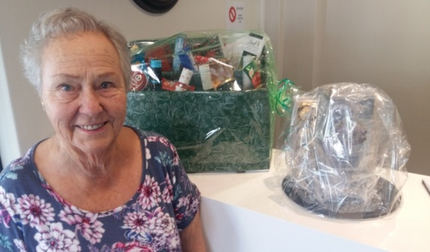

**Beautiful Christmas Hampers and a whisky hamper being raffled at Reception R10 a ticket. Contact Joan Jackson ext 2112 for more info.**

* **Have you found an interesting little keepsake to share with us at the CURIOSITY TABLE? We’ve got a swanee whistle and an 1867 maritime map – what have you got? Phone Viv t’Hart ext 2028.**
* **Have you made some JAM, PICKLES, PESTO, CHOCOLATE SAUCE OR SOMETHING for the Larder table**
* **There’s a variety of fascinating, useful and tasty things to buy for Christmas presents – have you diarised to stock up on cash?**
* **Latest addition is Laeeqah’s special range of shoes. Need some cash ☺.**
* **The CARE CENTRE CHRISTMAS TREE DECORATIONS are such a treat. You can buy them in sets or singles. Need some cash ☺.**
* **You can have very professional looking PERSONALISED MUGS AND TILES made up. Need some cash.**
* **And remember Sheila’s charming little pots of succulents. Need some cash.**
* **And MAUREEN’S WHITE ELEPHANT STALL - amazing things. Need some cash.**

**No cash needed to enjoy our CHOIR at 3.30pm singing songs from The King & I.**

* **Have you invited family and friends to come and experience an Evergreen Muizenberg Craft Market?**
* **Have you visited Reception to buy your tickets for tea/coffee and a delicious scone?**
* **Have you diarised to pack your picnic basket with everything you will need for the Bring ‘n Braai at 5pm after the market (eg. Meat, salad, rolls, cutlery, crockery, drinks, glasses.) Gas braais will be provided AND maybe some willing cooks.**

**REMINDERS: Lunch will be at 12 on Saturday 3rd November. No Canasta. Craft market Set-up 1.30. Start time 2.30. The POOL TABLE will be out of commission all day on the 3rd until 12pm on Sunday 4th**

**FOR MORE INFO: Please talk to Lydia ext 2017, Denise Ext 2320, Gill Pearson Ext 2203, Maureen ext 308, Sheila Hunt ext 135, Vivian B ext 2007, June ext 2018, and Ursula ext 101 from 27th (away until 26th).**