

**Newsletter 1st October 2018**

**GETTING TO KNOW YOU**

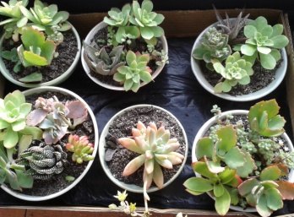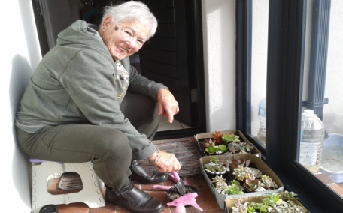**Sheila Hunt caring for the charming little pots of succulents for sale at the Craft Market from 2.30 pm on Saturday 3rd November. Look out for her table just as you enter the Craft Market area on Saturday 3rd. (Near Curiosities & Christmas tree decorations)**

**FOR YOUR DIARY: WHAT’S HAPPENING?**

**1ST October Monday: Craft Market committee meeting 2pm Board Room**

**4th October Thursday: * 3pm: Faranaaz, owner of RAINBOW EDUCARE talking to all at Book Club. This year’s Craft Market committee feels strongly that vital Early Childhood Development programmes should be supported nationwide. We have chosen to support well-run Rainbow Educare Centre at our end of Vrygrond Ave. Please come and be enthused by dynamic, hard-working Faranaaz. Donations raised from this year’s Craft Market will go to Rainbow Educare. (See notice boards.)**

**5th October Friday * 10am. Christmas Hamper Donation morning. Ursula will be in the library to receive your donations. Suggestions: Chocolates, toffees, sweets, special biscuits, Xmas pudding, Xmas cake, Brandy Butter, honey, jams, xmas serviettes, nuts – or maybe a turducken? *11am. Table Holders and Organisers meeting in TV lounge. * 11am: Gill Pearson will collect R20 per table from those intending to sell. (No table charge for displays or demonstrations).**

**17th October Wednesday. From today: tea/coffee tickets for Craft Market on sale at Reception. R20 each for tea or coffee and scone with cream and jam. R10 top-up tea or coffee only.**

***For some weeks Vivian B, June and Ursula and Erica have been making Christmas Tree decorations with the Care Centre folk. Its been such fun - singing - cake - colouring-in - punching - stringing - ipi-tombi - hymns, drakensberg boys choir -daar kom die Alabama. Then on Thursday we had a snow storm. Sheila delivered 32 crispy white handmade snowflakes. They are so beautiful. Here’s a hint***

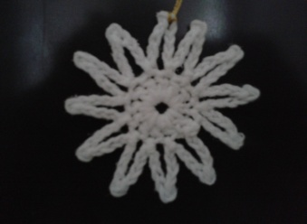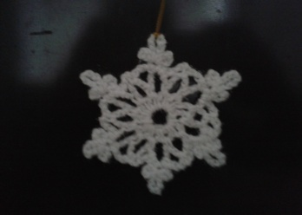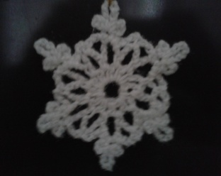

**Note from Ursula: **Thanks to all contributors of white elephant items and lovely donations for the Xmas Hamper. **Reminders: remember to bring everything you will need to the Bring n Braai (eg. Meat, salad, rolls, cutlery, crockery, drinks, glasses) we will provide the gas braais. ** Remember to send in a ‘hey-day’ photo of yourself to Di for the ‘Guess who’s who’ competition. **Remember, ESPECIALLY, to invite family and friends to the event. (Ursula x 101, (hamper donations) Maureen x 308 (white eles) Gill P x 2303 (money ) Reception x 9 tea tickets**