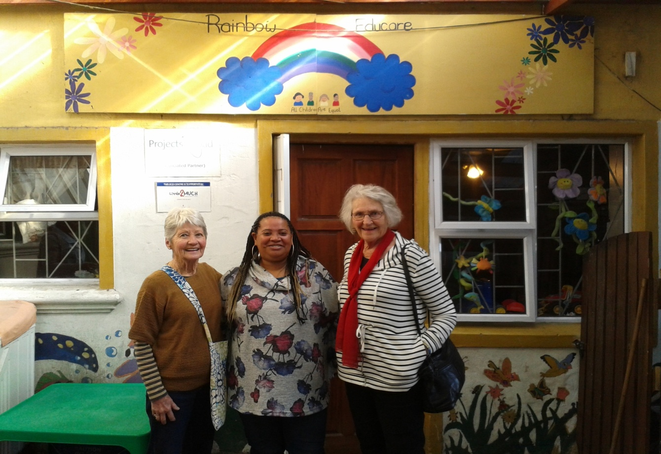

Ursula, Faranaaz – dynamic manager of beautiful RAINBOW EDUCARE in Vrygrond.

**DEAR RESIDENTS**

**PLEASE JOIN US AT BOOK CLUB 3PM THURSDAY 4TH OCTOBER 2018.**

**This year’s Craft Market committee feels very strongly that vital Early Childhood Development programmes should be supported nationwide, so, in our little neck of the woods we have chosen to support well-run Rainbow Educare Centre in Vrygrond Ave. (Yellow double storey visible from the M5). Owner Faranaaz will tell us at Book Club about their huge challenges – the red tape, health, hygiene and nutrition requirements, literacy training; about the two occupational therapists who work there; about the training of ECD teachers; about Vrygrond Library’s partnership.**

**She’s amazing. It takes dedicated, hard-working, upright people like Faranaaz to get SA’s social tranformation project going.**

**R12 per person for tea/coffee/eats and outreach kitty. All money raised will go to the Craft Market’s ECD Centre fund.**

**RSVP by Wednesday 3rd October to Reception**