MAY 2018 MOVIES

**2ND May, Wednesday – City of Joy - Free**

Farmer Hasari Pal (Om Puri) moves his family to Calcutta to start a new life. Settling in the city's poorest area (the "city of joy"), he finds Texan doctor Max (Patrick Swayze), who has been assaulted and robbed, lying in the street. Hasari takes him to his district, where the homeless and lepers live. Max becomes friends with Hasari and clinic doctor Joan (Pauline Collins), and Hasari gets a job as a rickshaw driver. Max soon plunges into his new life.

Time: 18H00



Duration: 2 hour 15 minutes

**6th May, Sunday – The Wilde Wedding: R5 PP**

After a whirlwind courtship, retired movie star Eve Wilde prepares to marry her fourth husband, the renowned English writer Harold Alcott. Sparks soon begin to fly when Eve's first ex and other guests arrive at her estate for a weekend get-together.

Time: 18H00



Duration: 1 hour 35 minutes

**13th May, Sunday – Atomic Blonde: R5 PP**

Sensual and savage, Lorraine Broughton is the most elite spy in MI6, an agent who's willing to use all of her lethal skills to stay alive during an impossible mission. With the Berlin Wall about to fall, she travels into the heart of the city to retrieve a priceless dossier and take down a ruthless espionage ring. Once there, she teams up with an embedded station chief to navigate her way through the deadliest game of spies.

Time: 18H00



Duration: 1 hour 55 minutes

**20th May Sunday, Show shank Redemption – R5 PP**

Andy Dufresne (Tim Robbins) is sentenced to two consecutive life terms in prison for the murders of his wife and her lover and is sentenced to a tough prison. However, only Andy knows he didn't commit the crimes. While there, he forms a friendship with Red (Morgan Freeman), experiences brutality of prison life, adapts, helps the warden, etc., all in 19 years.

Time: 18H00

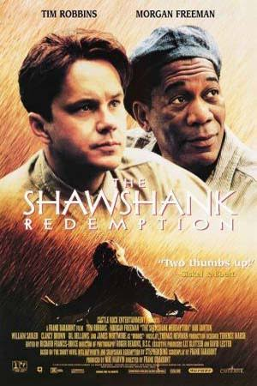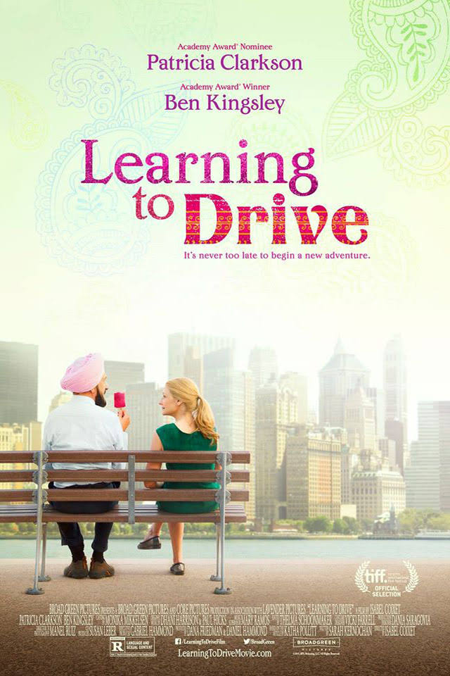

Cost: R16 Duration: 2 hour 22 minutes

**27th May, Sunday – Wonder - R5 PP**

Based on the New York Times bestseller, WONDER tells the incredibly inspiring and heart-warming story of August Pullman, a boy with facial differences who enters fifth grade, attending a mainstream elementary school for the first time

Time: 18H00



Duration: 1 hour 53 minutes