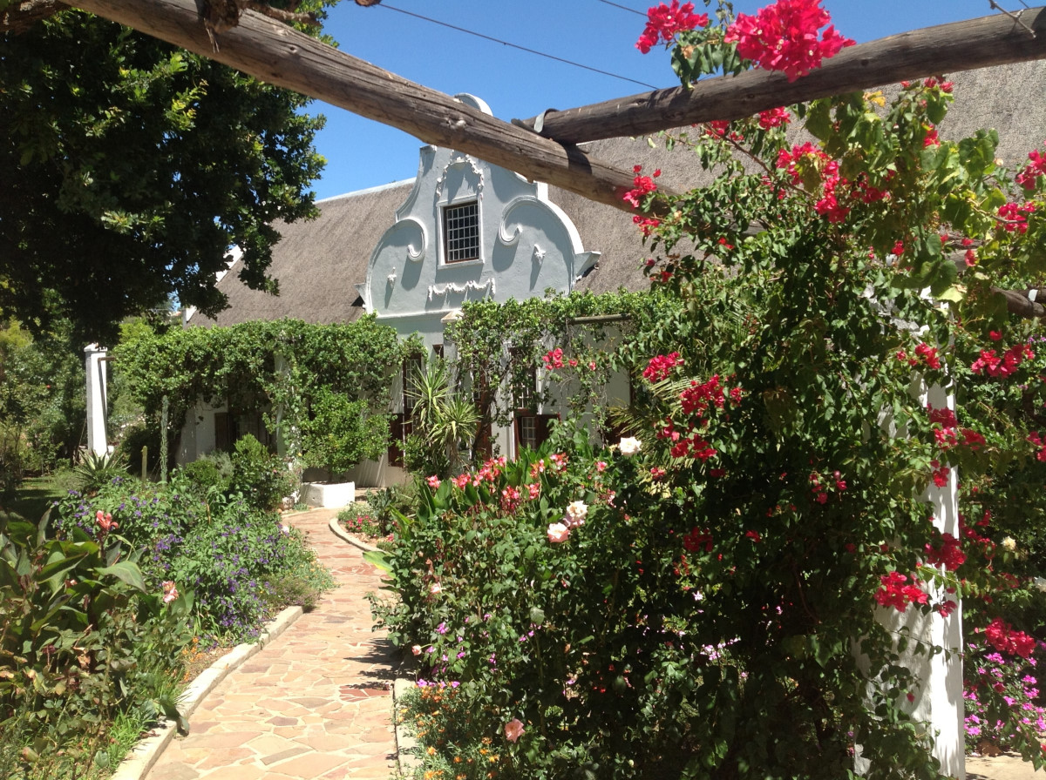

5 Vos Street, Tulbagh – www.wittedriftmanorhouse.com - +27 82 970 3703

"Your feet will bring you to where your heart is"

Dear Guest

A warm welcome awaits you at Wittedrift Manor House. Step back in time and walk into this impressive Cape Dutch home in the centre of Tulbagh. Just a short stroll from the historic Church Street, restaurants, museums and shops – a short drive to award winning wine estate, hiking and mountain biking trails and outdoor activities.
The Manor retains its grandeur by flaunting antique furniture, fine art collections and huge spacious rooms. Relax in a unique shady walled gardening setting, private front and back verandas, lounge next to a crystal clear swimming pool, or find a sunny corner to read a book. The enclosed garden provides a secure and safe off street parking, Teddy and Tango our resident dogs will be there to greet you and look after you while staying with us.
Wittedrift Manor House is a fully equipped self-catering manor house and comfortably accommodates up to 12 in three spacious suites. All the rooms are tastefully decorated in country colonial style.
PJ Daly and I would like to invite you to Tulbagh and to stay at the Manor House and enjoy the mid week special we have created for you.
50% discount mid week accommodation including a continental breakfast – we have weekend special prices as well
Plus The best for the guests specials and discounts and vouchers

Please quote Evergreen when making any inquiries or making a booking
Please find rates below and if you need any further information please do not hesitate to contact me directly
Kind Regards
Carol Collins
This year high season rates until the end April 2018 per room
The Schalkenbosch Family suite – sleeps up to 4 R2000.00
- Stratus 35sm boasts high ceilings, the queen sized four-poster yellowwood bedroom and is beautifully furnished in Cape Dutch antiques and Art. The twin room - Cumulus 19sm alongside sharing the en suite bathroom
The Saronsberg suite – 2 rooms both sleeping 2
- Full Circle boasts high ceilings, the queen sized four-poster yellowwood bedroom and is beautifully furnished in Cape Dutch antiques and Art with shower en suite. R1400.00
- The twin room – Seismic alongside with a private shower and bath. R1000.00
The Tara suite –2 rooms both sleeping 2
- Rachel Mary boasts high ceilings, the queen sized four-poster yellowwood bedroom and is beautifully furnished in Cape Dutch antiques and Art with shower en suite. R1400.00
- The twin room – George Alexander alongside with a private shower and bath. R1000.00
If the whole house is booked – sleeps up to 12 guests – R6800.00 per night for one night –
if you book for 2 nights or more R5500.00 per night – (long weekends and public holiday not applicable)

