OCTOBER MOVIES

**1st October Sunday 2017 – In the pursuit of happiness (Will Smith)**

Will Smith stars in the inspirational true story of Chris Gardner, a San Francisco salesman who’s struggling to make ends meet. When his girlfriend Linda walks out, Chris is left to raise their 5-year old son Christopher on his own.

Time: 18H00

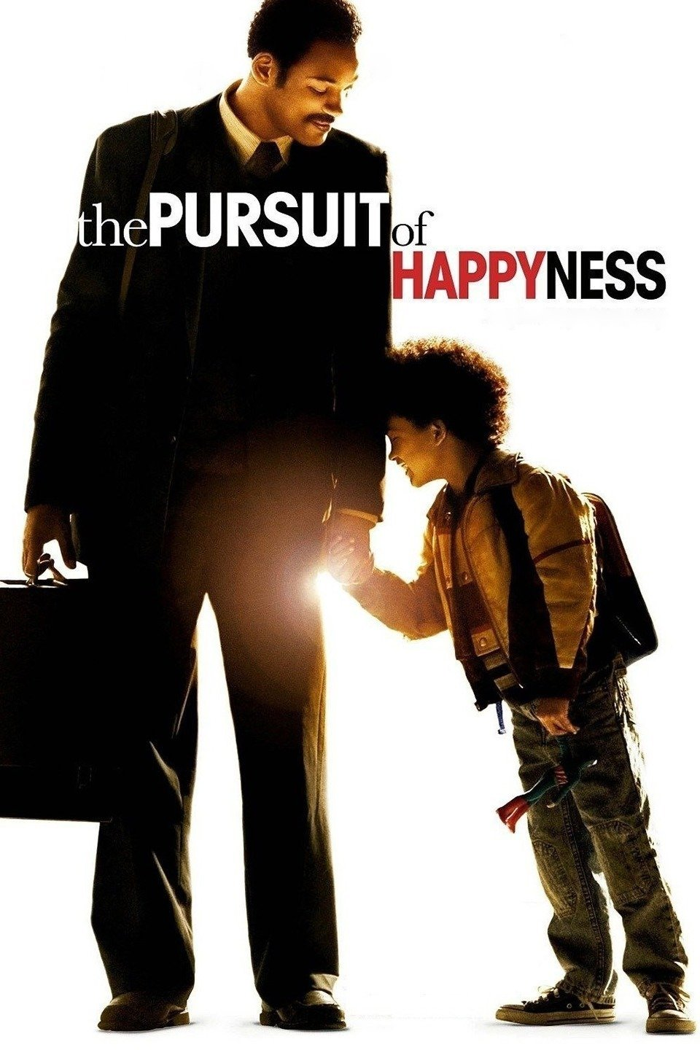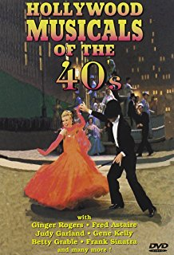 [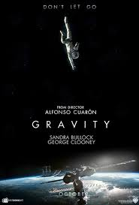](https://www.google.co.za/imgres?imgurl=http://poictesme.files.wordpress.com/2013/10/gravity-poster.jpg&imgrefurl=http://poictesme.com/film-review-gravity/&docid=qI6DgXP7fksnvM&tbnid=G5bQaTvG87ICiM:&vet=1&w=600&h=887&bih=985&biw=1920&ved=0ahUKEwjWxcatk4HVAhWBthoKHb2EBGUQMwixAShSMFI&iact=c&ictx=1)

Cost: No charge

Duration: 1 hour 17 minutes

**4h October Wednesday 2017 – Young Victoria (Emily Blunt)**

“Emily Blunt gives a stunning performance “from Academy Award Winners Graham King and Martin Scorsese (The Departed), along with academy Award winning screenwriter Julian Fellowes (Gosford Park) comes the young Victoria, the story of Queen Victoria ‘s early rise to power.

Time: 18H00

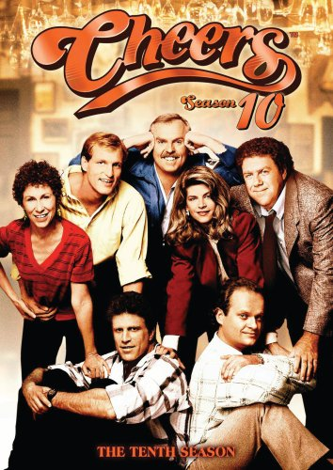 [](http://www.google.co.za/url?sa=i&rct=j&q=&esrc=s&source=images&cd=&cad=rja&uact=8&ved=0ahUKEwjjvMi6lIHVAhXKHxoKHRp9AV4QjRwIBw&url=http://filmpulse.net/tag/last-emperor-3d/&psig=AFQjCNExwS99inYbVU2DxZTb-hnKGbdR7g&ust=1499860103408751)

Cost: No charge

Duration: 1 hour 40 minutes

**8th Sunday October 2017 -John Deed Series Three (Martin Shaw)**

Good looking, fit and fifty-something, Judge John Deed is no ordinary High Court Judge. And neither is his uncompromising approach to justice that finds him flying in the face of convention, confronting corruption and taking on the establishment- especially pompous new Presider, Sir Monty Legover.

Time: 18H00

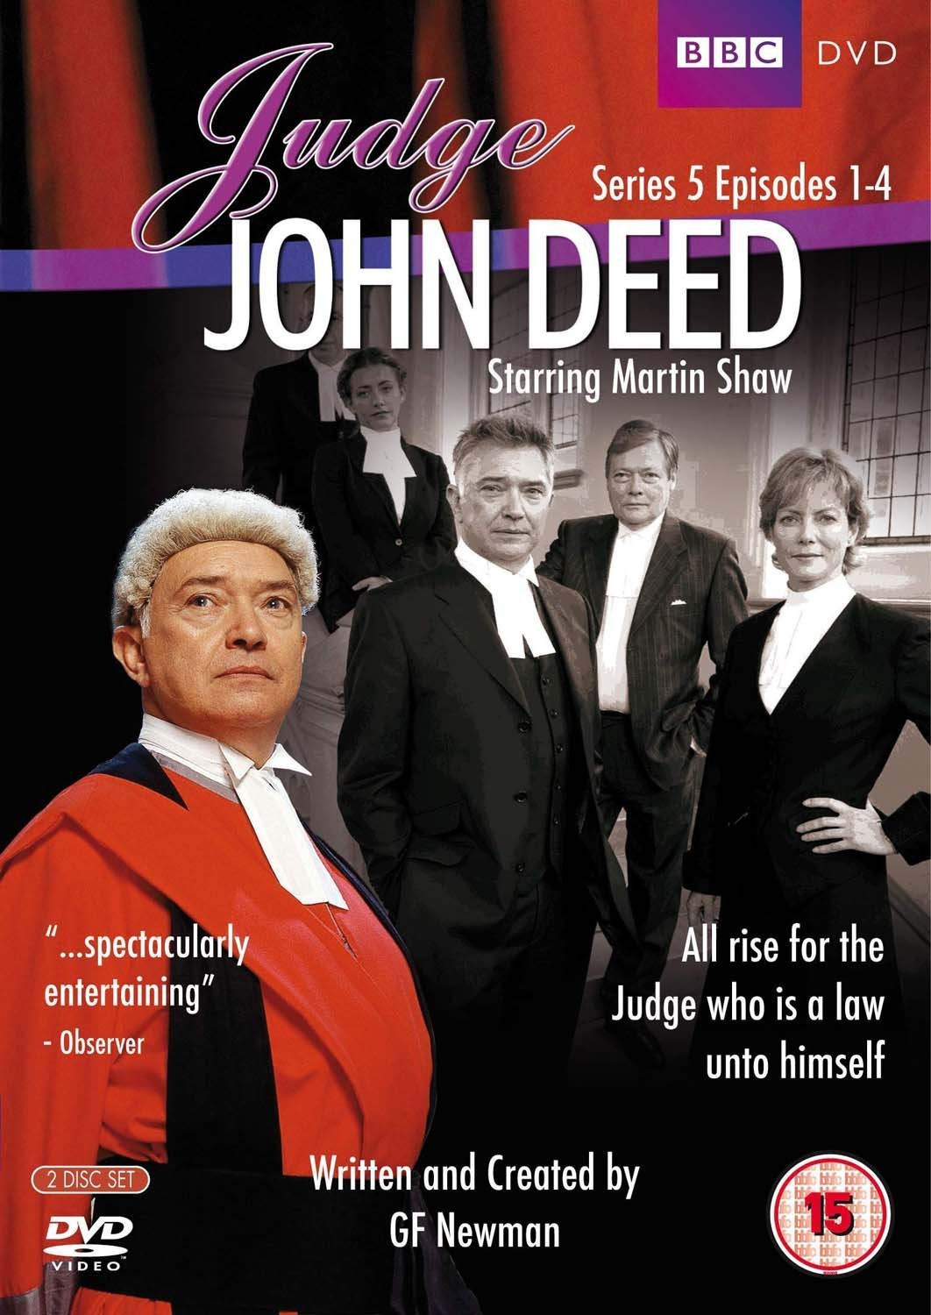[](http://www.google.co.za/url?sa=i&rct=j&q=&esrc=s&source=images&cd=&cad=rja&uact=8&ved=0ahUKEwid1_WLlYHVAhWBiRoKHTgIDWgQjRwIBw&url=http://www.rogerebert.com/reviews/under-siege-2-dark-territory-1995&psig=AFQjCNEJjR5p2d0wd4AldYihk1HMnJ_A1g&ust=1499860278184068)

Cost: No charge

Duration: 2 hour 58 minutes

**15th  Sunday October 2017 – Before Midnight (Ethan Hawke, Julie Delpy)**

Jesse and Celine first met in their twenties in before sunrise reunited in their thirties in before sunset, and now in director Richard Linklater’s amazing before midnight, they face the past, present and future; family, romance and love.

Time: 18H00

[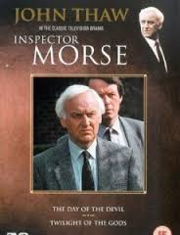](https://www.google.co.za/imgres?imgurl=http://img4.bdbphotos.com/images/230x300/b/c/bcwm8w9uss12.jpg?skj2io4l&imgrefurl=http://www.famousfix.com/topic/inspector-morse-death-is-now-my-neighbour&docid=zYAp2_PaqsG8QM&tbnid=BWwfyPzno99EnM:&vet=1&w=230&h=300&bih=985&biw=1920&ved=0ahUKEwiViJWdloHVAhVENhoKHTMUDWUQxiAIGigF&iact=c&ictx=1)

Cost: R16 Cost: No charge

Duration: 1 hour 44 minutes

**22nd Sunday October 2017 – De Ja Vu (Denzel Washington)**

Academy award winner Denzel Washington (Best actor, Training Day,2001) joins forces with blockbuster producer Jerry Bruckheimer and mega – hit director Tony Scott for Déjà vu – the powerful, fast -paced action-thriller with a spectacular mind-bending twist.

Time: 18H00

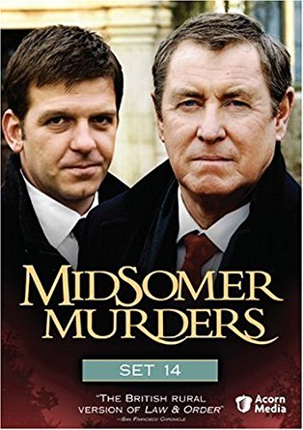[](https://www.google.co.za/imgres?imgurl=http://img.moviepostershop.com/river-dance-movie-poster-1995-1010270542.jpg&imgrefurl=http://www.moviepostershop.com/river-dance-movie-poster-1995&docid=UHyWchw0nR5GJM&tbnid=k4RSw3QpLTeZWM:&vet=1&w=270&h=400&bih=985&biw=1920&ved=0ahUKEwijvKuYnoHVAhUIWRoKHYZ3AF8QxiAIFigB&iact=c&ictx=1)

Cost: No charge

Duration: 2 Hours

**25th Wednesday October 2017 – Notting Hill (Hugh Grant, Julia Roberts)**

Anna Scott is the world’s most famous movie star. Her picture has been plastered on the cover of every magazine, and every time she makes a move, the entire world knows about it. William Thacker owns a travel bookstore. His business is stagnant, he has a roommate from hell. And since the divorce, his love life is completely non- existent.

Time: 18H00

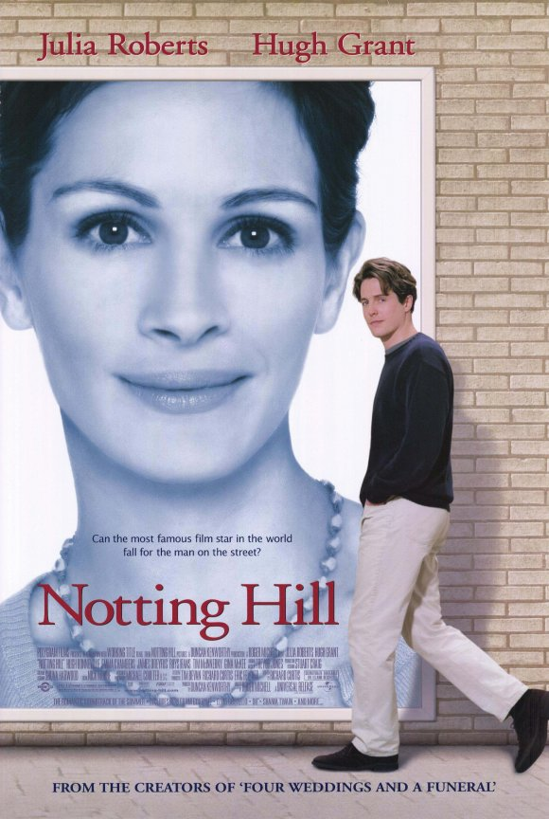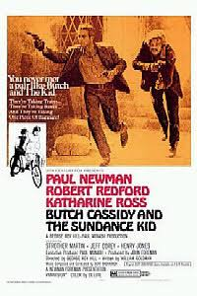[](http://www.google.co.za/url?sa=i&rct=j&q=&esrc=s&source=images&cd=&cad=rja&uact=8&ved=0ahUKEwiqzcujn4HVAhUGXRoKHfB1B2cQjRwIBw&url=http://www.imdb.com/title/tt0238112/&psig=AFQjCNHR8IastR4RD1fZuGj-Rfyb5nutJA&ust=1499863012004983)

Cost: No charge

Duration: 2 hours

**29th Sunday October 2017 – Lost in translation (Bill Murray, Scarlett Johansson)**

Bob (Bill Murray) and Charlotte (Scarlett Johansson) are two American guests at a hotel in Tokyo. Bob is a movie star in town to shoot a whiskey commercial, while Charlotte is a young woman tagging along with her workaholic photographer husband. Unable to sleep, Bob and Charlotte cross paths one night in the luxury hotel bar.

Time: 18H00

[](http://www.google.co.za/url?sa=i&rct=j&q=&esrc=s&source=images&cd=&cad=rja&uact=8&ved=0ahUKEwiqzcujn4HVAhUGXRoKHfB1B2cQjRwIBw&url=http://www.imdb.com/title/tt0238112/&psig=AFQjCNHR8IastR4RD1fZuGj-Rfyb5nutJA&ust=1499863012004983)

Cost: No charge

Duration: 1 hour 42 minutes