JUNE MOVIES
4th June 2017, Sunday – Priscilla Queen of the Desert
They came. They conquered. They looked fabulous. This wonderfully inventive, visually stunning and incomparably funny Australian film about three drag performers braving the vast, rugged outback won the 1994 Academy Award for Costume Design.
Time: 18H00
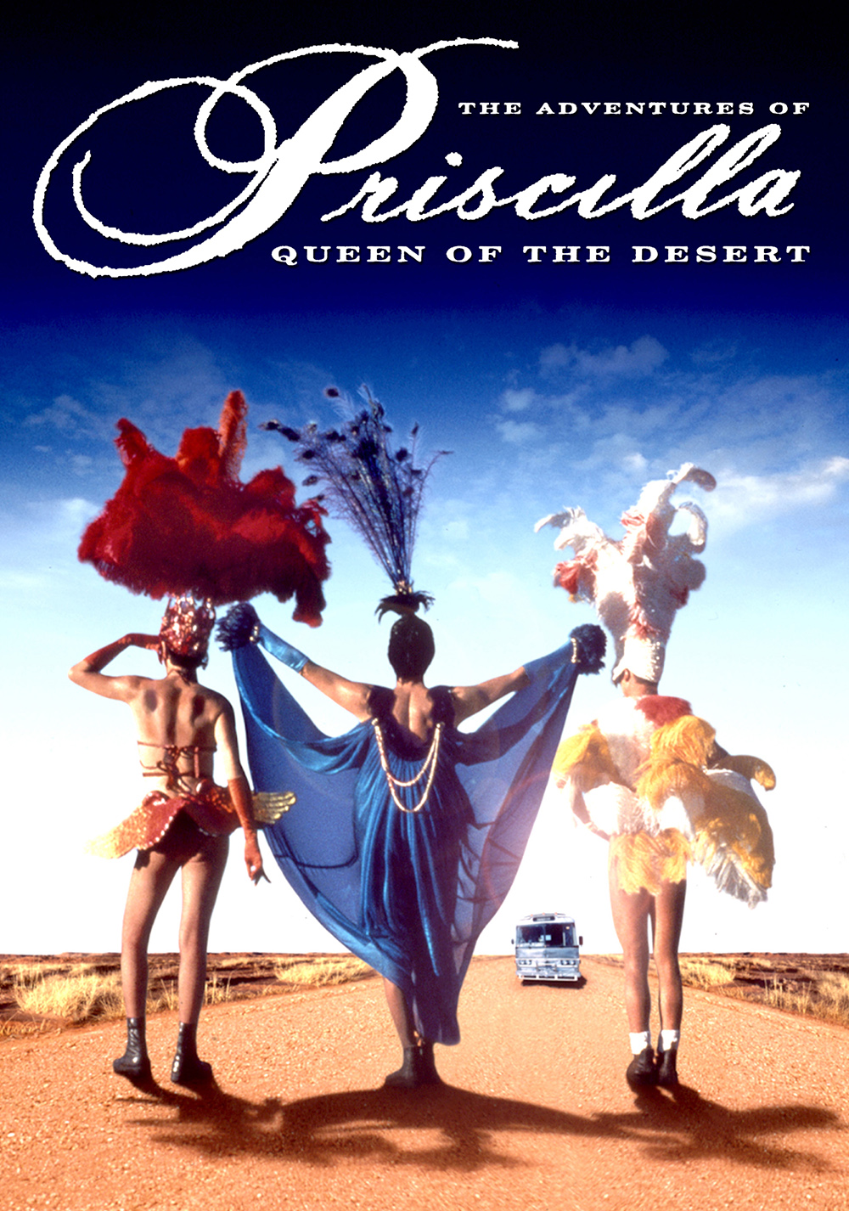
Cost: Free movie

Duration: 1 hour 39 minutes

7th June 2017, Wednesday – Bridge of Spies
A dramatic thriller set against the backdrop of a series of historic events, Bridge of Spies tells the story of James Donovan (Tom Hanks), a Brooklyn lawyer who finds himself thrust into the center of the Cold War when the CIA sends him on a near-impossible mission to negotiate the release of a captured American U-2 pilot.
Time: 18H00
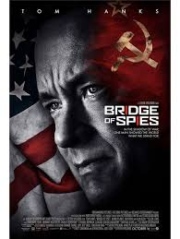

Cost: Free movie
Duration: 2 hours 15 minutes

11th June 2017 SUNDAY -Les Miserable
Set against the backdrop of 19th-century France Les Miserables tells an enthralling story of broken dreams and unrequited love, passion, sacrifice and redemption – a timeless testament to the survival of the human spirit.
Time: 18H00
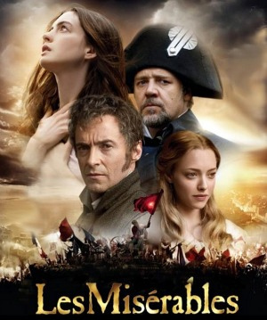
Cost: Free movie
Duration: 2 hour 31 minutes

18th June 2017, SUNDAY -Waking Ned
In the tradition of The Full Monty, Waking Ned entertains from start to finish …. a true crowd pleaser. A comedy about friends pulling together to make a dream come true.

Time: 18H00
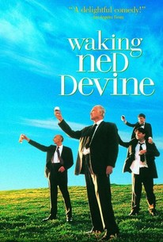
Cost: R16 Cost: Free movie
Duration: 1 hours 28 minutes

25th June 2017, SUNDAY – Edinburgh Military Tattoo 2007
Live from Edinburgh Castle Esplanade.

Time: 18H00
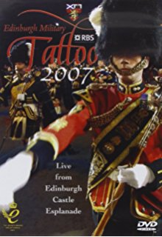
1

Cost: Free movie
Duration: 1 hours 30 minutes

28 June 2017, WEDNESDAY – Tinker Tailor Soldier Spy
When a disgraced spy surfaces with information concerning a double agent at the top of the British secret service, George Smiley (Gary Oldman), an ex-M16 agent, is drawn back into the murky field of espionage. Tasked with the investigation which of his trusted former colleagues has chosen to betray him and their country.

Time: 18H00
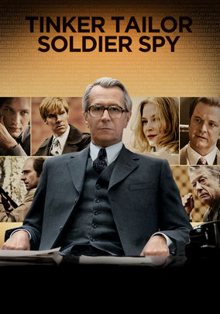
Cost: Free
Duration: 2 hours

