OCTOBER 2016 MOVIES
2 OCTOBER 2016, SUNDAY – SAVING MR BANKS (EMMA THOMPSON AND TOM HANKS)
This film reveals the surprising backstory behind the making of Mary Poppins.
Determined to fulfil a promise to his daughters, Walt Disney (Hanks) tries for twenty years to obtain the rights to author PL Travers (Thompson) book.
Time: 18H00
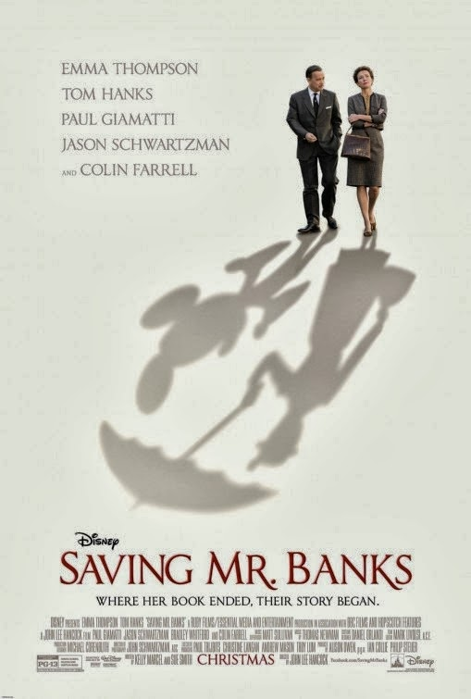
RSVP: Book directly with Amanda at reception
Cost: Free movie

Duration: 2 hours

9 OCTOBER 2016, SUNDAY – MUST LOVE DOGS
Sarah (Diane Lane) posts her profile on perfectmatch.com and finds she’s pursued by a bewildering array of weirdos. Then along comes a soulful boat builder (John Cusack) who’s not perfect, but he may be Mr Right if Sarah doesn’t pass him by.
Time: 18H00
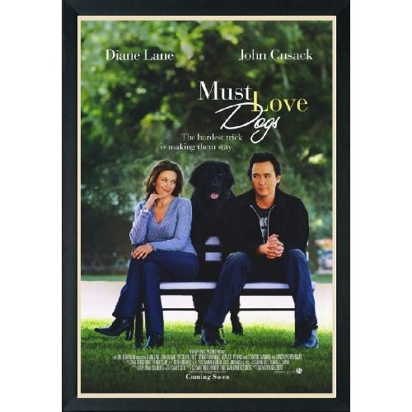
RSVP: Book directly with Amanda at reception
Cost: Free movie
Duration: 1 hour 38 minutes

12 OCTOBER 2016, WEDNESDAY – WALK THE LINE – JOHNNY CASH (STRONG LANGUAGE & DRUG USE)
Joaquin Phoenix powerfully portrays Johnny Cash, a passionate artist who rebelled against convention, revolutionized music and always walked his own path, regardless of the consequences. His troubled past, together with his outlaw persona, unbridled talent and passion for the woman he was destined to be with, led him on a path of self-destruction.
Time: 18H00
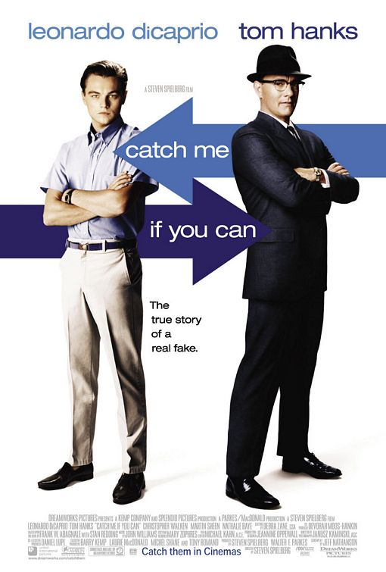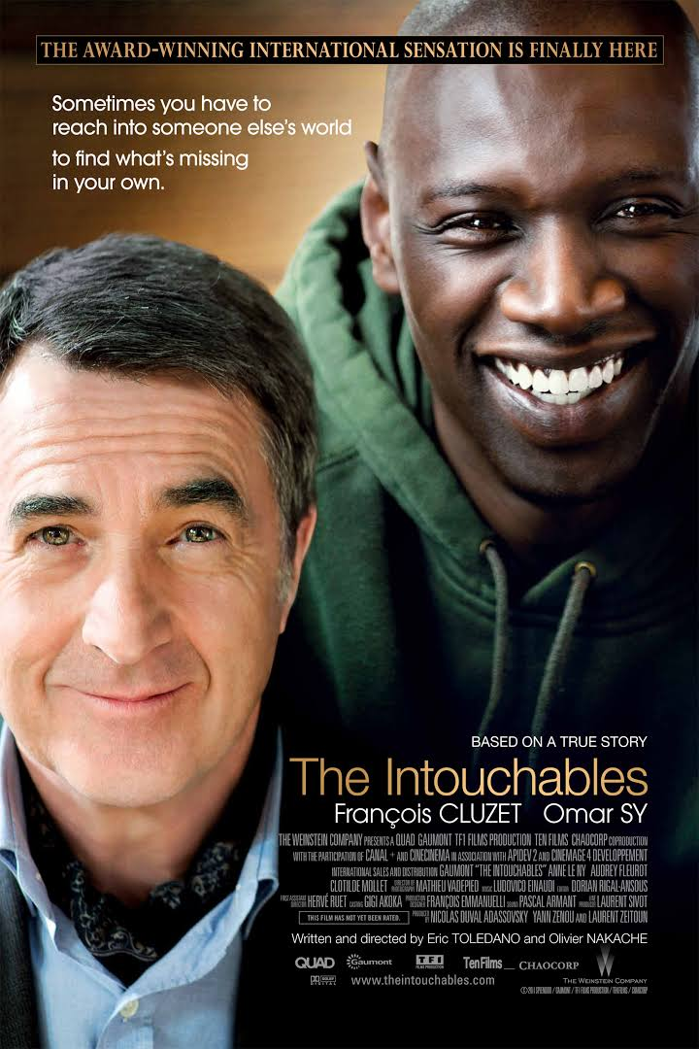
RSVP: Book directly with Amanda at reception
Cost: Free movie
Duration: 2 hours and 10 minutes

16 OCTOBER 2016, SUNDAY – YOU’VE GOT MAIL
Tom hanks and Meg Ryan are eager to hear three little words: You’ve got mail. A sparkling romantic movie.
Time: 18H00
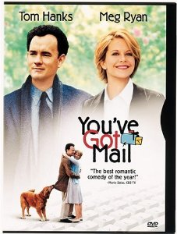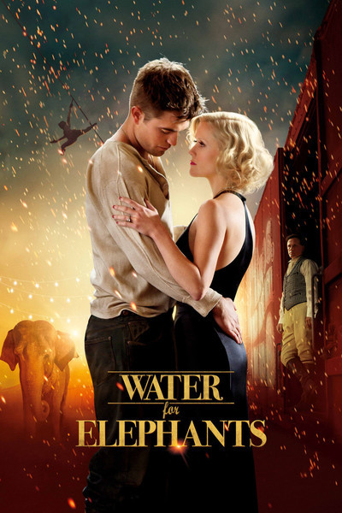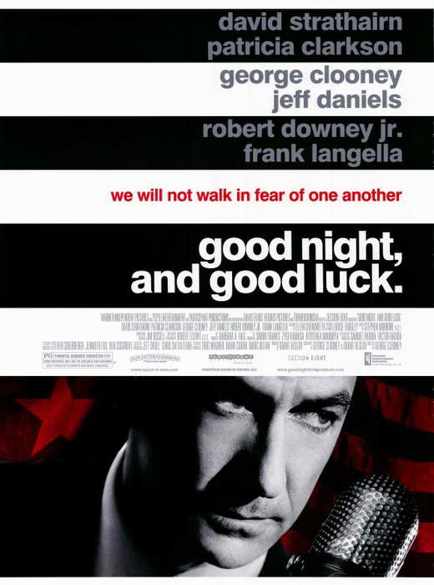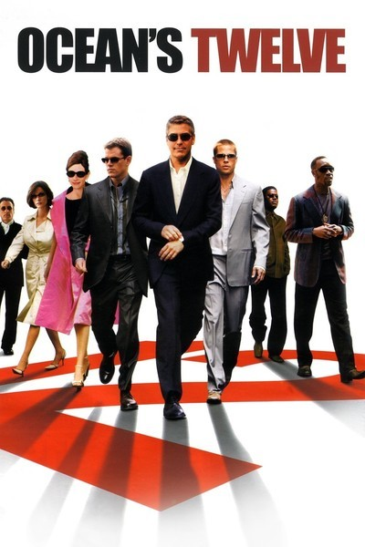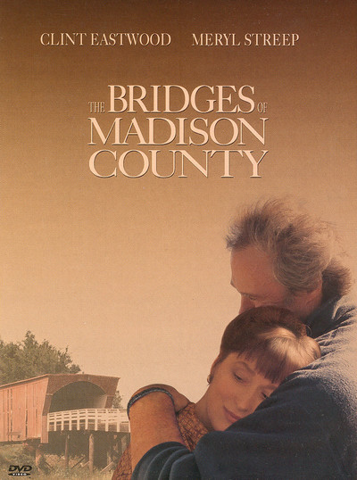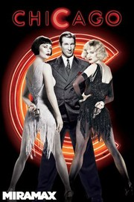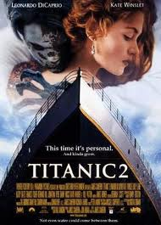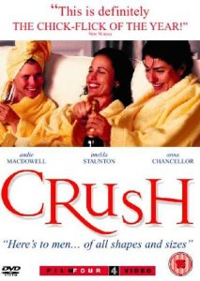
RSVP: Book directly with Amanda at reception
Cost: R16 Cost: Free movie
Duration: 2 hours

23 OCTOBER 2016, SUNDAY – THE QUIET AMERICAN
A prophetic story of love, betrayal and murder. American Aid worker Alden Pyle (Brendan Fraser) arrives in Saigon at the height of the Vietnamese fight for independence from French colonial rule. Filled with his zeal for his mission to help the people of Vietnam, Pyle befriends London times correspondent Thomas Fowler (Sir Michael Caine).

Time: 18H00
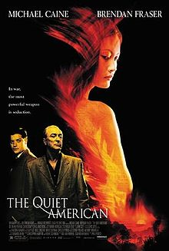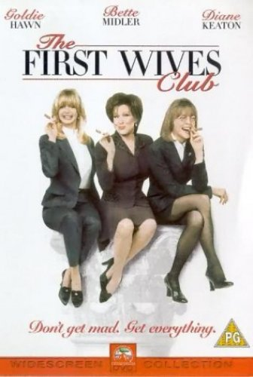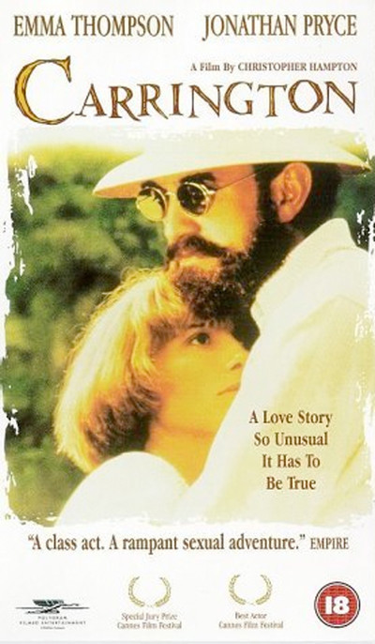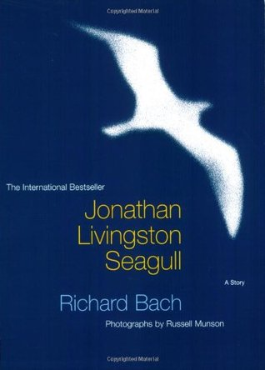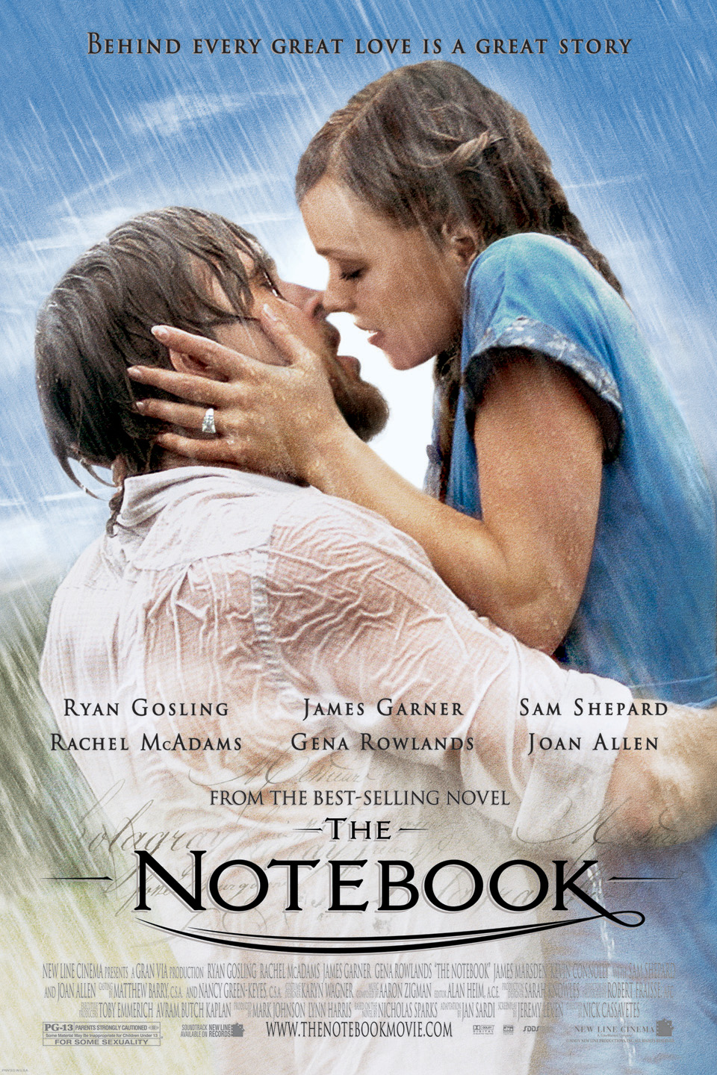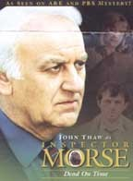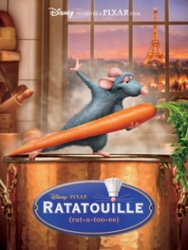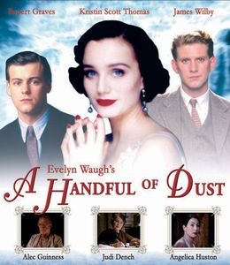
RSVP: Book directly with Amanda at reception
Cost: R16 Cost: Free movie
Duration: 1 hour 36 minutes

26 OCTOBER 2016, WEDNESDAY – THE HUNDRED FOOT JOURNEY
This uplifting story bursts with flavour, passion and heart. When the chilly chef proprietress of a Michelin-starred French restaurant in southern France gets wind of a culinary immigrant opening an Indian restaurant just 100 feet from her own, her icy protests escalate to all-out war between the two establishments.

Time: 18H00
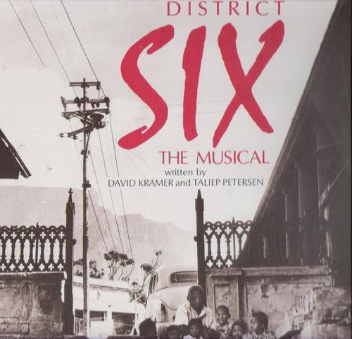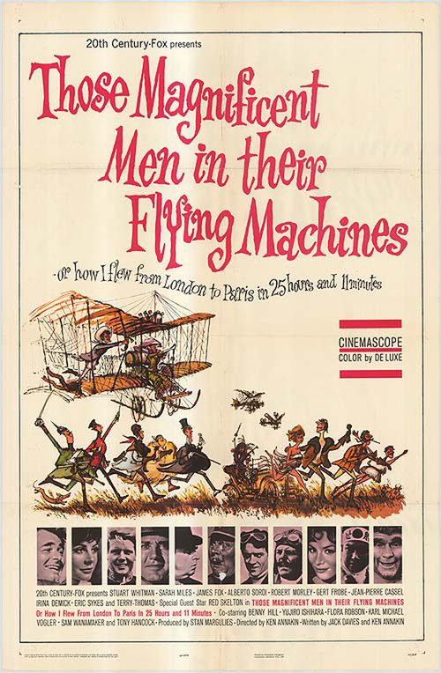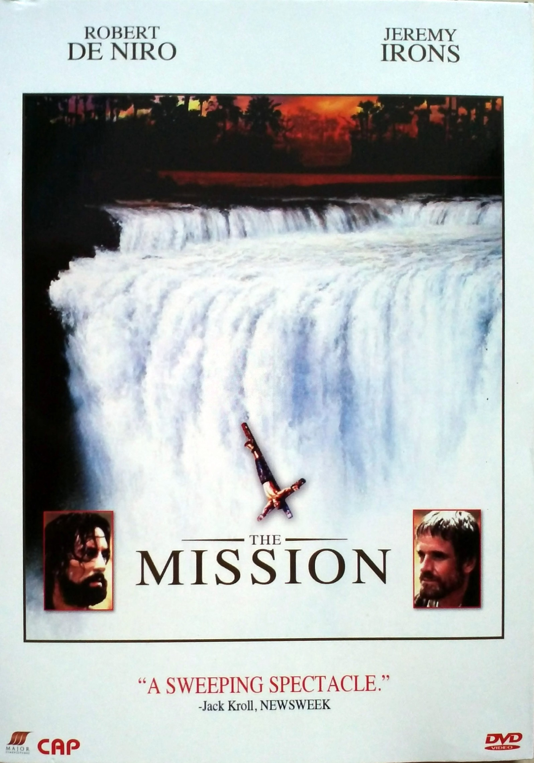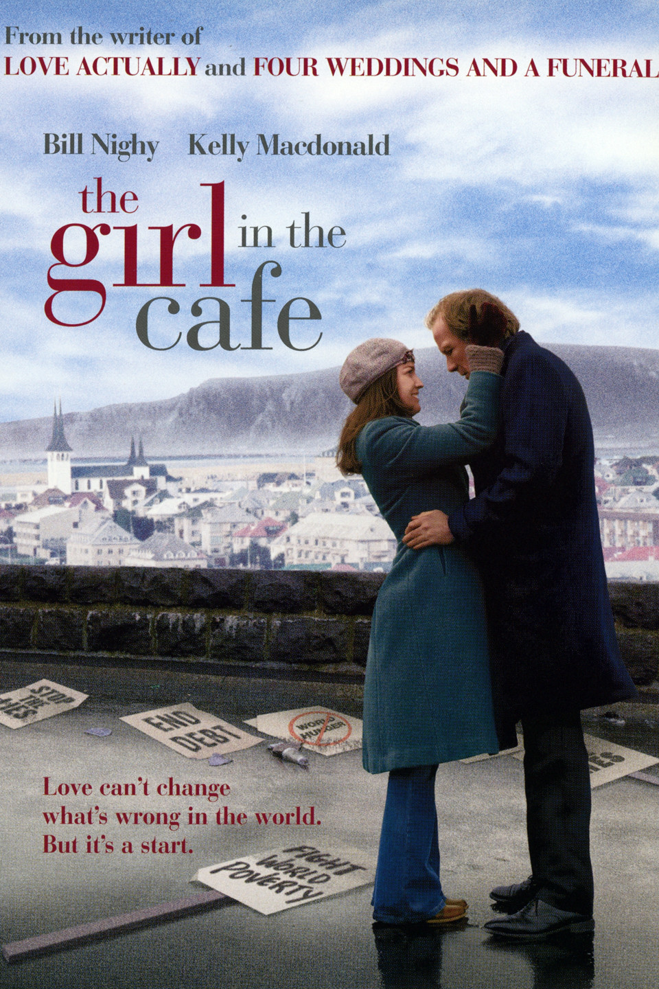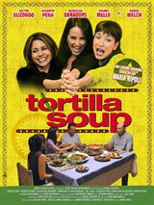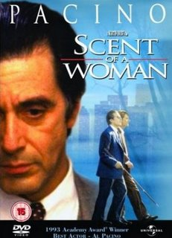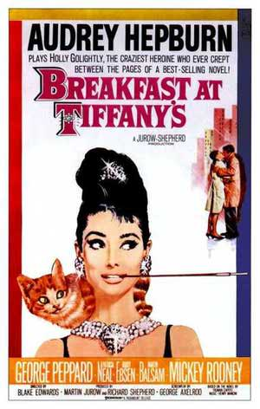
RSVP: Book directly with Amanda at reception
Cost: R16 Cost: R6 for the tea/coffee to be paid to the Bistro.
Duration: 1 hours 57 minutes

30 OCTOBER 2016, SUNDAY – ANDRE RIEU – MY AFRICAN DREAM (MUSICAL)
This is based on a real life documentary and docu-concert.

Time: 18H00
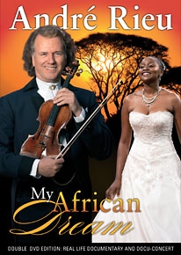
RSVP: Book directly with Amanda at reception
Cost: R16 Cost: Free movie
Duration: 3 hours

