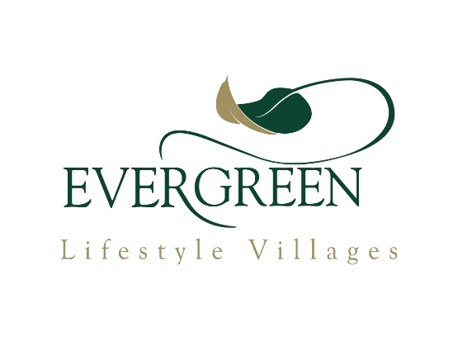

**EVERGREEN LAKE MICHELLE**

*(“the village”)*

### **QUESTIONNAIRE FORM**

For use by registered life right holders of the village, recorded in the Life Right Register, to be used at the Annual General Meeting to be held in the **Evergreen Noordhoek Lifestyle Centre, Glencairn Expressway, Fish Hoek, Cape Town, on Tuesday 23 July 2024 at 12h30.**

I/We (please print) _________________________________________________________________________

______________________________________ (name) of _____________________ (unit number)

being the holder(s) of a life right in the village, hereby wish to raise the following matters (see instructions below):

1. ___________________________________________________________________________

___________________________________________________________________________

__________________________________________________ (provide a brief description of the matter)

2. ___________________________________________________________________________

_________________________________________________________________________

__________________________________________________ (provide a brief description of the matter)

# Signature/s ______________________________________ date: