**“As the leaves fall this autumn – make sure you don’t” +1**

**Ageing Well and Fall Prevention through Exercise.**

What are falls and why should we care?

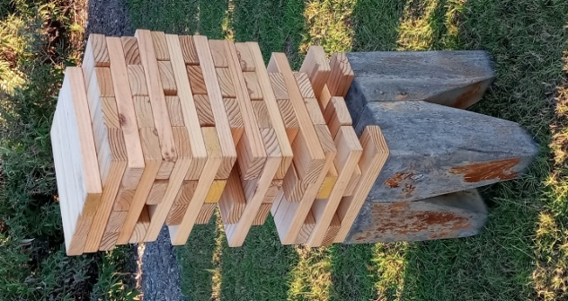**The Facts and Stats:**

1. 30% of people over 65 years of age fall annually
2. Of those who fall 25% suffer serious physical injury – hip fractures
3. After a fall, an older person has a 50% probability of having impaired mobility and a 10% probability of dying within the year
4. Falls destroy confidence, increase isolation and reduce independence.
5. Biggest risk factor for falling is “Fear of Falling” from a previous fall.
6. An appropriate exercise programme designed for the older person can reduce falls by 54%. *2.

Sounds rather a gloomy prognosis, but let’s be positive, let’s be counterintuitive and not think ‘Falling” ….we need to think – MOVE MORE! Our bodies are designed for movement.

Principles are the same as the Jenga balance tower; strong foundations for stable and upright posture.

**The reasons for falling in later life:**

* Deteriorating Eye sight
* Diminished Hearing
* Foot fitness and health -reduced sensory receptors sending messages to brain (poor fitting footwear, arthritis).
* Medication (dizziness) and medical conditions

Combinations of the above age related conditions and diminished muscle strength contribute to a loss of balance (and proprioception). We know we slow down as we age but, slowing down should not mean moving less!

**The intervention and Prevention**

We can take early preventative measures against falling and one of the most effective interventions that we can do for ourselves is to take appropriate EXERCISE which includes balance and strength work. *“Fall prevention exercise has been proven to be extremely effective in reducing falls”. *3.*

The earlier we start working on balance to improve posture, confidence and strength the better.

**In summary**

Prevent a first fall and reduce the fear of subsequent falls!

Tai Chi is an excellent activity as well as dance. Chair based exercise when modified to include standing exercises and balance, can achieve beneficial results for preventing a first fall. Workouts with elements of Pilates for core strength and mobility of the spine can lift the spirits and improve posture and confidence. When we exercise the body – the brain gets a workout too.

Judith Peck



*1. Age UK – Staying Steady

*2 Age UK – Falls Prevention Exercise –following the evidence

*3. Newcastle University, Biomedical Research Centre in Ageing and Chronic Disease – Ageing Well and Fall Prevention