This is a special price list for Evergreen residents. I have agreed to consolidate all
interested residents orders, please mark on the order form your requirements and send it to me before end of April so i can place 1 bulk order, hopefully one of their first deliveries when they are permitted to do so thanks Brian 96 phoenix1@absamail.co.za
 | 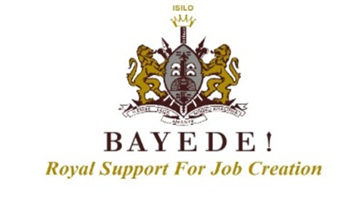
SPECIAL PRICE LIST 2020/2021
PRODUCT  750ml BOTTLE | PER 750ML BOTTLE  EXCL. VAT | PER 750ML BOTTLE  INCL. VAT 15% | PER CASE OF  6 X 750ML  INCL. VAT | PER CASE OF  6 X 750ML  INCL. VAT 15%
BAYEDE! XO CAPE BRANDY
BAYEDE! XO Cape Brandy | R1 130 | R1 299,50 | R7797.00 | R7 797,00
THE KING RANGE
HMK Goodwill Jubilee | R97,17 | R111,75 | R670.45 | R670,47
HMK Goodwill Shiraz | R80,07 | R92,08 | R552.48 | R552,48
THE KING SHAKA-ZULU RANGE
King Shaka-Zulu Chenin Blanc | R50,00 | R57,50 | R345.00 | R345,00
King Shaka-Zulu Pinotage | R50,00 | R57,50 | R345.00 | R345,00
,
Queen Nandi MCC Brut Rose | R119,00 | R136,85 | R821.10 | R821,10
The Princess Chardonnay Pinot Noir | R76,00 | R87,40 | R524.40 | R524,40
THE SHIELD RANGE
The Prince Cabernet Sauvignon | R48,24 | R55,48 | R332.85 | R332,86
The Prince Merlot | R48,24 | R55,48 | R332.85 | R332,86
The Prince Sauvignon Blanc | R48,24 | R55,48 | R332.85 | R332,86
The Prince Pinotage | R48,24 | R55,48 | R332.85 | R332,86
B ROYAL RANGE
B Royal Pinotage | R42,00 | R48,30 | R289.80 | R289,80
B Royal Chenin Blanc | R42,00 | R48,30 | R289.80 | R289,80

