|  |
| --- |
|  |

|  |
| --- |
|  |

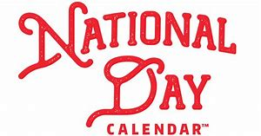

*January*

* 1st New Year’s Day
* 2nd National Personal Trainer Awareness Day
* 4th National Trivia Day
* 5th National Bird Day
* 6th National Shortbread Day
* 12th National Sunday Lunch Day
* 15th National Hat Day
* 19th National Popcorn Day
* 21st National Hugging Day
* 23rd National Pie Day
* 24th National Compliment Day
* 27th National Chocolate Cake Day
* 29th National Puzzle Day
* 30th National Croissant Day
* 31st National Hot Chocolate Day

*February*

* 2nd National Freedom Day
* 3rd National Carrot Cake Day
* 4th National Homemade Soup Day
* 6th National Frozen Yoghurt Day
* 7th National Wear Red Day
* 9th National Pizza Day
* 14th National Organ Donor Day
* 17th National Random Acts of Kindness Day
* 23rd National Banana Bread Day

*March*

* 1st National Self-Injury Awareness Day
* 3rd National Anthem Day
* 3rd National Soup it Forward Day
* 6th National Oreo Cookie Day
* 7th National Crown of Roast Pork Day
* 12th National Pancake Day, Plant a Flower Day and World Kidney Day
* 13th National Good Samaritan Day
* 15th National Shoe the World Day
* 17th St Patrick’s Day
* 21st National Quilting Day
* 26th National Nougat Day

