|  |
| --- |
|  |

|  |
| --- |
|  |

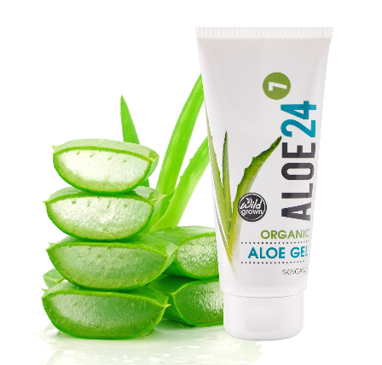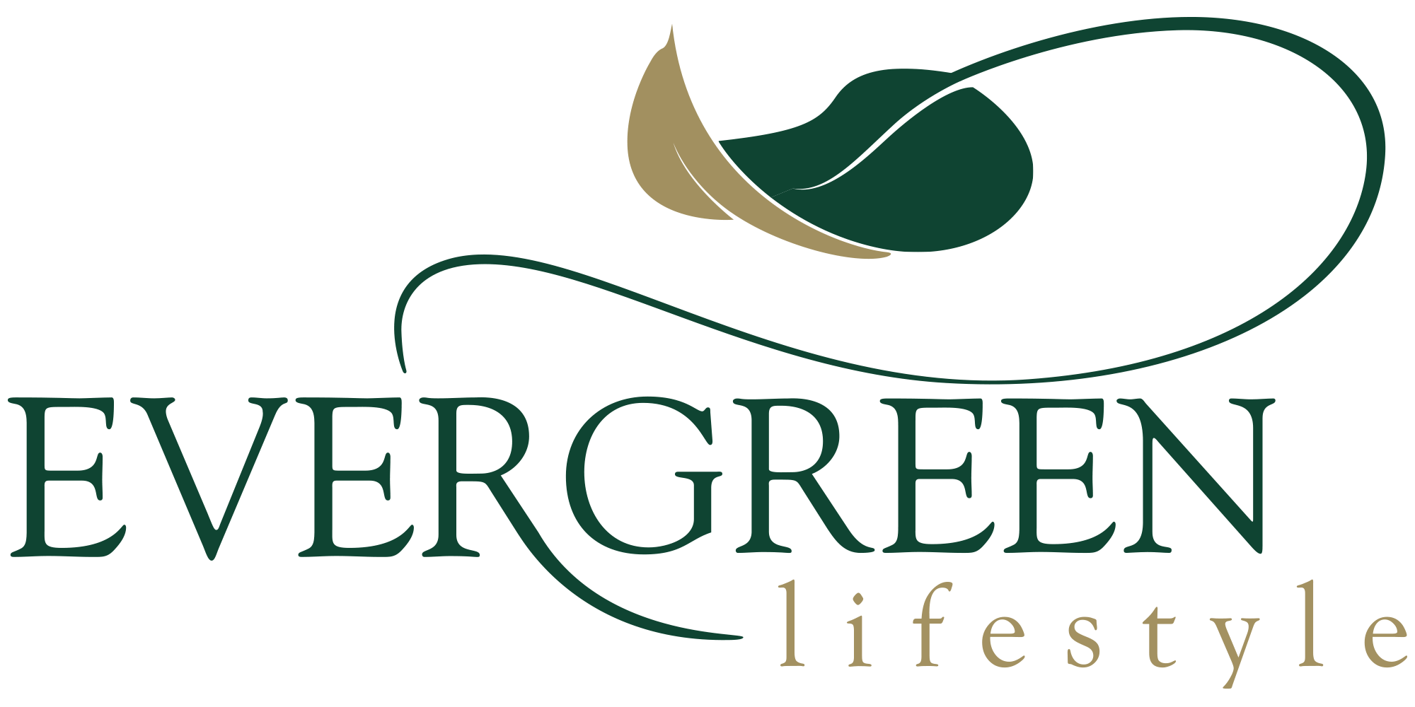

**Presentation on the benefits of Aloe Gel for mature skin**

*Hosted by Barbara from*

*Totally Wild*

**Our company, Totally Wild (Pty) Ltd, is a 12-year old Cape Town based company, specialising in a small range of the medicinal type of aloe juices (used as a general tonic as well as to treat problems of the digestive tract), and also an organic aloe gel for the skin.  I have personally been involved in the aloe industry for the past 27 years and have seen some truly remarkable results when people have used aloe to treat a really wide range of issues.  Attached is a document informing you more about our Aloe 24/7 organic aloe gel.**

Venue: Noordhoek Bistro

Time: 10h00

Date: 9th August 2019

Special on the day cash price of R80 per tube

