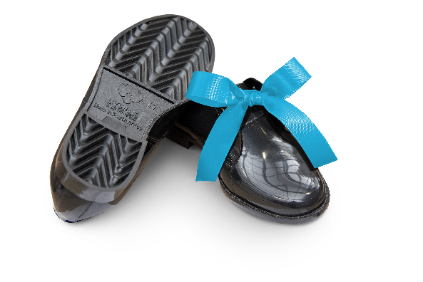
- Too many South African learners have no shoes, and are going to school barefoot.
- Millions of used, non-hazardous hospital PVC drip bags, oxygen masks and associated tubing destined for landfill, can be recycled into premium-quality products such as school shoes.
- Just 20 drip bags are needed to make one pair of new school shoes.
- An innovative partnership between Netcare and Adcock Ingram Critical Care represents a step in the right direction, so that children won’t have to go to school barefoot or without the appropriate shoes.
- This initiative is sustainable over the long term, also offering environmental benefits, enterprise development and job creation opportunities.

Help South Africa’s Learners Step into Greatness

Thank you for reaching out to us showing your generosity to offer a gift of dignity and help one of South Africa’s future leaders who currently walk barefoot to school “Step into Greatness” by donating a pair of My Walk recycled school shoes at only R35 per pair!

Millions of learners in South Africa unfortunately still don’t have school shoes to wear, and go to school barefoot or without the appropriate shoes. In addition to providing learners with much-needed shoes that will make their daily educational journey easier, the initiative simultaneously helps to save scarce resources.

My Walk, a non-profit organisation that is supported by Netcare and Adcock Ingram Critical Care, recycles uncontaminated Polyvinyl Chloride (PVC) drip bags, oxygen masks and associated tubing to manufacture durable and fully recyclable school shoes that are then laced up, packaged with love, and distributed as a gift of dignity to children in the lower LSM schools at no cost to the children and the school. This is made possible by the generous donations of corporations, individuals and civil society organisations who believe in the validity of the dreams and aspirations of underprivileged learners in South Africa.

A prototype of the school shoes was tested at three schools in 2019, in order to get first hand feedback from learners on the design and comfort. The final unisex shoe design took into consideration the valuable feedback received from the learners.

Since inception, My Walk has recycled 63 367kgs of healthcare waste and produced a total of 114 461 pairs of shoes! We believe, based on research, that there are more than 5 million children in our country who do not have a pair of shoes. We aim to ultimately reach each and every one of these children and help them “Step into Greatness”.

The Chief Director: National and Provincial Communication in the Ministry of Basic Education, Mr Elijah Mhlanga, welcomed the initiative, saying: “School shoes are a basic necessity, and if learners do not have adequate footwear, this can introduce ongoing obstacles to their education including bullying and harassment at school. Having school shoes can enhance the schooling experience for learners. Many learners unfortunately still walk long distances to and from school without shoes, facing a daily threat of sustaining cuts and infections.”

The school principal of one of the My Walk recipient schools, Chivirikani Primary School, Mr Christopher Maluleke, said: “School shoes mean more than just completing the uniform. When children don’t have shoes, it can affect their personal dignity and self-esteem, which may negatively impact their school experience, academic performance and potentially hold them back from participating in games and sports. Wearing fit for purpose school shoes can help bolster children’s confidence and self-esteem and have an all-round positive effect on their journey of development and learning, so that they can be better equipped for the future.”

The My Walk partnership is an example of embracing a circular economy. It shows how a green solution can fulfil a material need for a business while simultaneously benefitting society – in this case by supporting education, job creation and enterprise development. The partnership further demonstrates the meaningful and wider impact that an innovative approach to solving business challenges can have.

This initiative, that has an amazing positive impact in the lives of our children, our planet and our economy, is a great passion for all of those involved! Thank you for taking the time to read about this worthy initiative. Please feel free to contact me if you need any additional information.

Kindest regards,
Delanie Bezuidenhout (General Manager: My Walk)
(delanie.bezuidenhout@adcock.com / 079 520 2559)

