MONDAY | TUESDAY | WEDNESDAY | THURSDAY | FRIDAY | SATURDAY | SUNDAY
 |  |  |  |  |  | 1
2 | 3 | 4 | 5 3pm Petanque  10am Visual Music  House 81 | 6  9am Beginners Line Dancing  9.30am Line Dancing – Main Class  10.30am Bible Study 12.30pm Fish & Chips lunch  5pm Waterhole | 7 | 8
9  NATIONAL WOMAN’s DAY  Due to public holiday, there will not be a therapeutic water aerobics class | 10 | 11  10am Art Class | 12  15:00  ANNUAL GENERAL MEETING  10am Visual Music  House 81 | 13  9am Beginners Line Dancing  9.30am Line Dancing – Main Class  10.30am Bible Study 12.30pm Fish & Chips lunch  5pm Waterhole  10am Visual Music  House 81 | 14 National Lemon Meringue Day  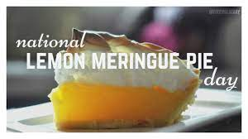 | 15
16  National Tell a Joke Day  9am Therapeutic Water Aerobics  10am Art Classes  10am Knit & Natter  5pm-7pm Pool & Waterhole | 17  09-12 SASHNI AUDIOLOGIST  9am Therapeutic Exercise Classes  2.30pm Embroidery Class  2.30pm Scrabble  5-7pm Ladies Pool | 18  10am Art Class  6pm Social Dinner | 19  2pm Bridge  3pm Petanque  6pm Movie Night | 20  9am Beginners Line Dancing  9.30am Line Dancing – Main Class  10.30am Bible Study 12.30pm Fish & Chips lunch  14:30 BINGO  5pm Waterhole | 21  National Senior Citizens Day | 22
23  9am Therapeutic Water Aerobics  10am Art Classes  10am Knit & Natter  5pm-7pm Pool & Waterhole | 24  9am Therapeutic Exercise Classes  2.30pm Embroidery Class  2.30pm Scrabble  5-7pm Ladies Pool | 25  10am Art Class  6pm Social Dinner | 26  2pm Bridge  3pm Petanque  6pm Movie Night | 27  9am Beginners Line Dancing  9.30am Line Dancing – Main Class  10.30am Bible Study 12.30pm Fish & Chips lunch  5pm Waterhole | 28  National Bow Tie Day  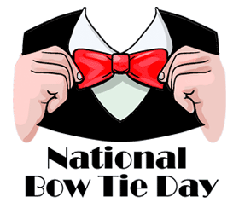 | 29
30  9am Therapeutic Water Aerobics  10am Art Classes  10am Knit & Natter  5pm-7pm Pool & Waterhole | 31  9am Therapeutic Exercise Classes  2.30pm Embroidery Class  2.30pm Scrabble  5-7pm Ladies Pool
August 2021

