**DR SUMI PADAYACHEE**

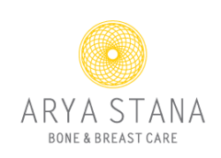

**ARYA STANA BONE & BREAST CARE**

**A state of the art, dedicated breast & bone imaging centre**

To acknowledge Breast Cancer awareness month & World Osteoporosis Day, we invite you to join us for an informative talk on Breast & Bone Health and the importance of screening tests.

**Early Detection Saves Lives …**

**DATE:** 26 August 2022

**TIME:** 10:00

**VENUE:** Evergreen Lifestyle Village, Bergvliet