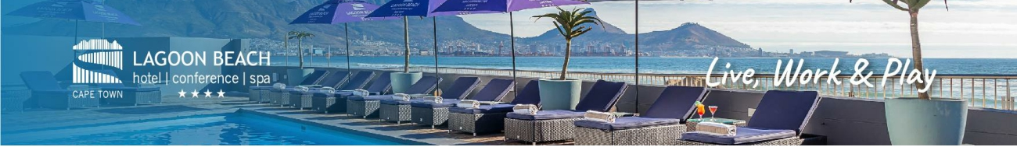

**“Retirees Cape Town Retreat”**

Retired and looking for a safe and indulgent escape in the Cape, then look no further. We are the only hotel in Cape Town with direct access to the beach. Enjoy a stroll on the sand, a relaxing Spa treatment or a sunset cocktail at our La Mizu Beach Bar. Close proximity to the Milnerton Golf Course, Canal Walk Shopping Centre and The V&A Waterfront, the possibilities are endless.

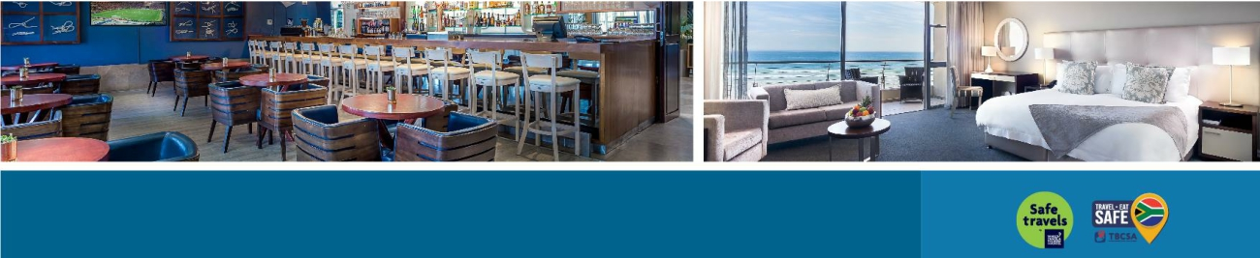3ecThis offer includes:

• 2 nights stay for 2 sharing guests in a Classic Room

• Full Breakfast

• 1 Dinner for 2 guests (a la carte meal)

• Uncapped Wi-Fi

• Complimentary undercover parking

• Complimentary scheduled transfers to Canal Walk and

The V&A Waterfront

**R2099**

**2 Sharing Guests**

**2 Nights including Breakfast**

**1 Dinner**

Valid until 31 July 2021 T’s & C’s apply:

When booking - quote the booking code:

60PLUS

THIS OFFER IS ONLY VALID FOR GUESTS OF 60 YEARS AND OLDER

Contact Cheryl | 082 411 7672 | cheryl@suregiltedge.com