RESTAURANTS IN THE AREA DOING DELIVERIES

 | Lime Tree Café (Restaurant & Pizzeria)  From 08:30 – 18:30  021 712 1497  Cash or Card
 | The Brasserie  From 12:00 – 18:30  021 712 1363  Cash or Zapper
 | Col’Cacchio – Meadowridge  From 11:00 – 18:30 (R20 Delivery fee)  021 712 3190  Cash, Card, Zapper, Snapscan
 | Peddlars  From 13:00 – 19:00  021 794 7747  EFT, Zapper or Cash
 | Rock Sushi Thai  From 11:00 – 19:00 (R25 Delivery fee)  021 712 2921  Cash or Card
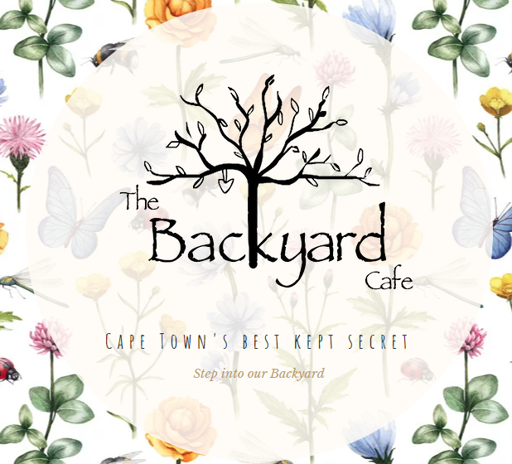 | The Backyard Café  From 09:00 – 17:00  061 524 4753 (Order via Whatsapp)  021 713 1220  Credit, cash or EFT

