



Donald Campbell is going to give a short talk and slide show on his recent Namibian trip on Tuesday 21st May in the clubhouse commencing at 6.30pm and will last 20 minutes.

We ask that residents be seated by 6.15pm.

**EVERGREEN APARTMENTS**

The 22 Evergreen Bergvliet apartments are almost complete. The final touches are being undertaken and the finishes are being installed. The project team is almost ready to handover to the sales division for marketing.

The three-bedroom apartments with luxury finishes are really beautiful and have outstanding views of the mountains.

The contractors are working very hard to get everything ready and we expect the first sales to be concluded by June and the new residents to move in shortly after that.



**CASINO ROYALE THEME DINNER**

FRIDAY, 31 MAY 2019

R165.00 per person

Clubhouse - 6.30PM

You are welcome to bring your own liquid refreshments

**Dressing up is not obligatory**

**MOVIE NIGHT**

**- *WOMAN IN GOLD -***

SATURDAY, 1 JUNE 2019 AT 7:00pm



Maria Altmann, an octogenarian Jewish refugee, takes on the Austrian government to recover artwork she believes rightfully belongs to her family. She did so not just to regain what was rightfully hers, but also to obtain some measure of justice for the death, destruction, and massive art theft perpetrated by the Nazis.

You are welcome to bring your own refreshments. Please contact Paddy Fordyce on Ext 152 for any additional information. Our movie nights will be screened on first Saturday of the every month.

**WEDDING ANNIVERSARIES  
MAY/JUNE 2019**



We wish to congratulate Colin & Dawn Osborne, David & Felicity Walker and Trevor & Heather Honneysett who celebrate their wedding anniversary in May.

Congratulations to David & Inez Gretton and Dave & Jacky Orton who celebrate their anniversaries in June.



**MEDICAL UPDATE**

WEDNESDAY, 29 MAY AT 10:30AM

Unique Health will be doing a presentation to village residents on its service and the various care plans offered by them.

The presentation will end with a Q&A session and will be followed by tea.

Please contact reception on Ext 300 and confirm your attendance for catering and seating purposes.

**SUNDAY ROAST LUNCH**

19 MAY 2019 - 12:30

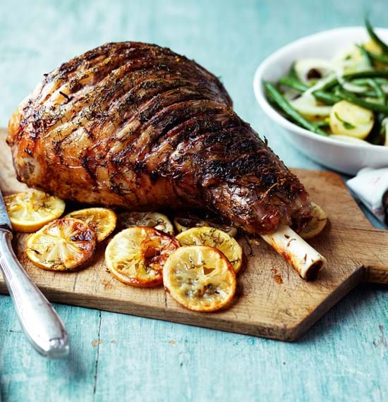

Traditional Roast Lamb and roast potatoes served with seasonal vegetables followed by a delicious dessert, tea/coffee

R180.00 per person

Please book and pay for lunch at reception or call Ext 300 by no later than Thursday, 16 May 2019

Please phone Yvonne Whitford (Ext 114) for any additional information.



Our monthly Lucky Draw is a way to raise funds by the Village Entertainment Committee to provide live music, décor and a variety of items for the benefit of resident functions.

One ticket costs R20.00 /three tickets cost R50.00.

The draw sheet is available at reception.

Buy your ticket for our next draw which will take place on **Tuesday, 28 May 2019**

|  |  |  |
| --- | --- | --- |
| **BIRTHDAYS**  **MAY 2018** | | |
| 5th | Anne Jordan | Unit 23 |
| 6th | Charles Harrod | Unit 13 |
| 7th | Trish Smith | Unit 67 |
| 10th | Jo Nixon | Unit 36 |
| 15th | John Bester | Unit 34 |
| 15th | David Lyall | Unit 28 |
| 19th | Ursula Keanly | Unit 11 |
| 21st | Elda Diana-Oliaro | Unit 55 |
| 31st | Mark Dry | Unit 63 |



FIBRE-TO-THE-HOME

VOX PRESENTATION

THURSDAY, 16 MAY at 10AM

We have arranged an information session on FTTH with Vox Telecoms on Thursday, 16 May at 10am in the clubhouse.

Marco Hamilton, FTTH Manager will be happy to answer any of your questions on fibre and the related data and voice packages on offer.

Please confirm your attendance for this event to reception on Ext 300 by no later than Wednesday, 15 May for seating purposes



FRIDAY 28 JUNE at 6PM

Our popular pub night takes place on Friday, 28 June at 6pm. It will include some light snacks and mingling with residents.

Please make every effort to attend as it promises to be a fun evening. Tickets for sale at reception or on the night.

All Welcome.

|  |  |
| --- | --- |
| **CALENDAR OF EVENTS**  **2019** | |
| **MAY 2019** | |
| Wed,15 | Music Concert – 7pm |
| Thurs,16 | Fibre Presentation – 10am |
| Sun, 19 | Sunday Roast Lunch – 12.30 |
| Mon, 20 | Security Presentation - 10 am |
| Tues, 21 | Donald Campbell’s Namibian slide show – 6.30pm |
| Wed, 29 | UH Presentation – 10.30am |
| Fri, 31 | Casino Royale Dinner – 6.30pm |
| **JUNE 2019** | |
| Sat, 1 | Movie Night – 7pm |
| Wed, 5 | Men’s Breakfast – 9am |
| Thurs, 6 | Norval Gallery Outing – 10.00 |
| Thurs,6 | Ladies Bridge |
| Sun, 16 | Sunday Roast Lunch – 12.30 |
| Wed,19 | Music Concert – 7pm |
| Wed , 26 | UH Presentation – 10.30am |
| Fri, 28 | Pub Night – 6pm |
| **JULY 2019** | |
| Thu, 4 | Men’s Breakfast – 9am |
| Thu, 4 | Ladies Bridge |
| Sat, 6 | Movie Night – 7pm |
| Wed, 17 | Music Night – 7PM |
| Fri, 19 | Bingo |
| Sun, 21 | Sunday Roast Lunch-12.30 |
| Fri, 26 | Xmas in July Dinner – 6.30PM |
| Wed, 31 | UH Presentation – 10.30am |
| *\*Events are subject to change without notice* | |

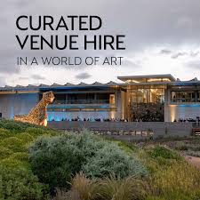

**NORVAL FOUNDATION/**

**ART MUSEUM**

**FIRST THURSDAY**

6 JUNE 2019 AT 10.00AM

The Norval Foundation opens its doors every First Thursday of the month from 10am – offering free admission to all!

We are planning a trip to the Norval Foundation gallery on Thursday, 6 June. - a centre for art and cultural expression dedicated to the research and exhibition of 20th- and 21st-century visual art from South Africa and beyond.

The Sculpture Garden, outdoor amphitheatre, purpose-built exhibition spaces and research library are situated in a unique setting that offers visitors a multisensory experience. This is complemented by the Skotnes Restaurant and Bar.

Transport to and from the gallery will be provided at a nominal rate and lunch will be for your own account.

We will depart from the clubhouse at 10.00am and return to the village at 2.30pm. The foundation is meant to be experienced at a slow, leisurely pace – so ensure that your feet are comfortable enough to do plenty of walking around.

Lunch can be enjoyed at the Skotnes Restaurant, overlooking the foundation’s serene wetland and Sculpture Garden. The restaurant is open from 12pm – 3pm.

Please confirm your attendance for this event at reception by no later than Monday, 26 May for transport purposes. Please call Shawn at reception on Ext 300 to book your seat.

**BERGVLIET BISTRO**

**COFFEE SHOP**

DAILY LUNCH SPECIAL – R48



WPC have launched a “daily lunch special” which is a light and delicious meal offering great value for money at only R48.00 per meal - every weekday, Monday to Friday.

The sale of our meals provided by Western Province Catering (WPC) in the Bistro are picking up.

Residents are thoroughly enjoying the ease and convenience of having somewhere to “pop” in for lunch or coffee and cake with their friends and family.

Account and card facilities are available.

SONNET 18

Shall I compare thee to a summer's day?   
Thou art more lovely and more temperate:  
Rough winds do shake the darling buds of May,  
And summer's lease hath all too short a date:   
Sometime too hot the eye of heaven shines,  
And often is his gold complexion dimm'd;   
And every fair from fair sometime declines,  
By chance, or nature's changing course, untrimm'd;  
But thy eternal summer shall not fade  
Nor lose possession of that fair thou ow'st;  
Nor shall Death brag thou wander'st in his shade,  
When in eternal lines to time thou grow'st;   
So long as men can breathe or eyes can see,  
So long lives this, and this gives life to thee.

***William Shakespeare***



**MUSIC EVENING**

WEDNESDAY, 15 MAY AT 7PM

Please join Herman Poelmann for his monthly music concert which will held in the clubhouse.

The first winter series will showcase Henry Vieutemps’ Violin Concerto N. 4 in D minor Op. 31 performed by the German Chamber Orchestra of Bremen conducted by Paavo Järvi with Violinist: Hilary Hahn.

The second part of the concert features W A Mozart’s Symphony No.38 in D Major K 504 (Prague) at the B B C Proms in 2017, played by the Chamber Orchestra of Europe and conducted by Bernard Haitink.

Please book at reception (300) on or before Tuesday 14.05.2019 at noon to facilitate seating. Light salty snacks are provided, but bring your own drinks.

Duration of this show is 1 hour and 10 minutes.

|  |  |  |
| --- | --- | --- |
| **BIRTHDAYS**  **JUNE 2018** | | |
| 3rd | John Whitford | Unit 14 |
| 4th | Gill Cooper | Unit 10 |
| 5th | Lyn Law | Unit 38 |
| 6th | Julie Phillips | Unit 56 |
| 14th | Lidi Cummins | Unit 20 |
| 15th | Felicity Walker | Unit 42 |
| 20th | Paula Searson | Unit 78 |
| 21st | Anne Lawton | Unit 51 |
| 28th | Yvonne Whitford | Unit 14 |
| 28th | Elnor Leach | Unit 19 |

**EXTERNAL MAINTENANCE**

BLACKLAND PAINTERS

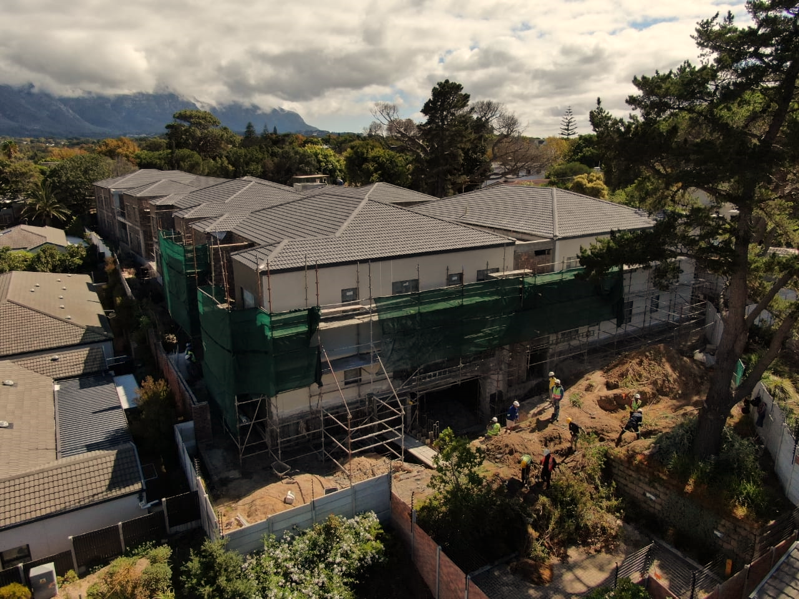

The external maintenance of the houses in our village has been underway for the past month. Our newly painted houses look very smart.

The contractors are working hard to meet the deadline of 30 May and we are all looking forward to seeing the end product.

We thank you for your patience and understanding whilst they complete this undertaking.

**SECURITY PRESENTATION**

MONDAY, 20 MAY 2019 – 10AM



Grinnell Security will be hosting an awareness presentation around security issues and protocols for our residents as a safety awareness campaign.

It will cover some interesting topics and things to do or not to do in the event that you observe suspicious people, vehicles or activities.

Tea will be served after the presentation.

Please contact reception on Ext 300 and confirm your attendance for catering and seating purposes.

**MEN’S BREAKFAST**

WEDNESDAY, 5 JUNE at 9AM

Please join us for our monthly men’s breakfast at 9am in the Clubhouse on Thursday, 6 June.

Please make every effort to attend. Book with Shawn at reception or call Ext 300.

Price R70pp. All Welcome.

For additional information, please call Ton Weber on Ext 105



**BALANCE & TONE CLASS**

EVERY MONDAY at 10AM

A weekly group Balance & Tone class has commenced and takes place every Thursday at 10am in the Games Room.

Classes are R400 p/m.

For more information or to join the class please contact Claire direct on 0832030309.