Christy-Lyn 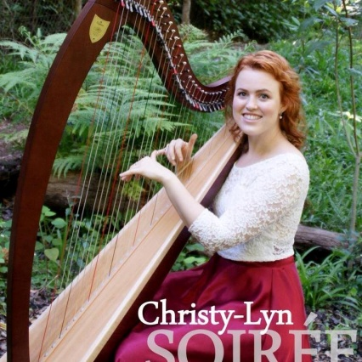

Will sing for us in theManor house at7.00p.m. on Wednesday 14June(Bring/share & socialise at 6.00 p.m. before her show)

Christy-Lyn – This beautiful young lady sings like an angel & plays the harp like you have never heard before. Finalist in “Voice of South Africa with lots of Overseas experience.

She will do a mixture of Love songs, “Can’t help falling in love, Scarborough fair ”etc, Celtic Songs & Classical Pieces

Cost-R70p.p. Call Andrea Ext 300 to book.

Family & Friends Welcome!!!.

Ronnie & Toetie van Reenen

p.p. Events & Entertainment Committee.