Announcement!!!

Japanese Theme Dinner

Friday 27 January 6.30 for 7.00p.m.

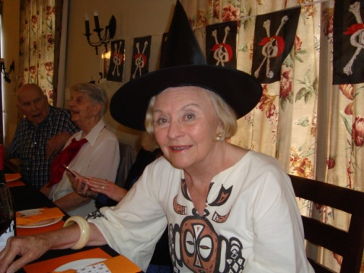 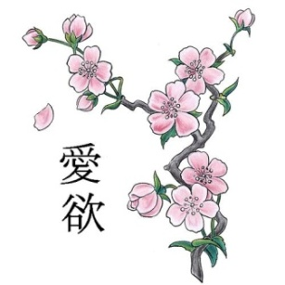 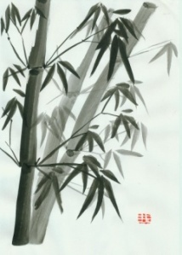

Our very own “Annemarie Renaud” lived in Japan with her late husband Ray (Top man in Coca Cola Japan) for 5 years where she learned the language, the customs, the art, floral arrangements, traditional dress, the food & much more.

She has kindly agreed to give us a short insight into the lives of the Japanese people at 6.35p.m. on Friday.

We have been engrossed by her knowledge/love of Japan,

Ronnie & Toetie

