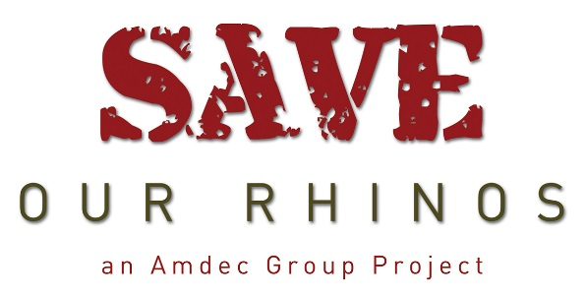

1st April 2016
Dear fellow conservationist
Where did the first quarter of 2016 disappear? The April page of the calendar features a yawning lion, so relax and enjoy his company over the next 30 days.
Recently, I was lucky enough to spend a week at a private lodge in the Mjejane Game Reserve on the Crocodile River; sadly, the day before we arrived, a Rhino had been shot by poachers but before they could hack off the horn they were disturbed by Kruger National Park anti-poaching rangers. The Rhino was de-horned by KNP officials to deter the poachers from returning.
These brave young men and women risk their lives every day and it is my intention this year to once again donate to the SANParks Honorary Rangers.
I’m sure that StopRhinoPoaching.com will forgive me for “poaching” the following information from their website which graphically illustrates just how ruthless the poachers are; this is a war which needs to be waged together.
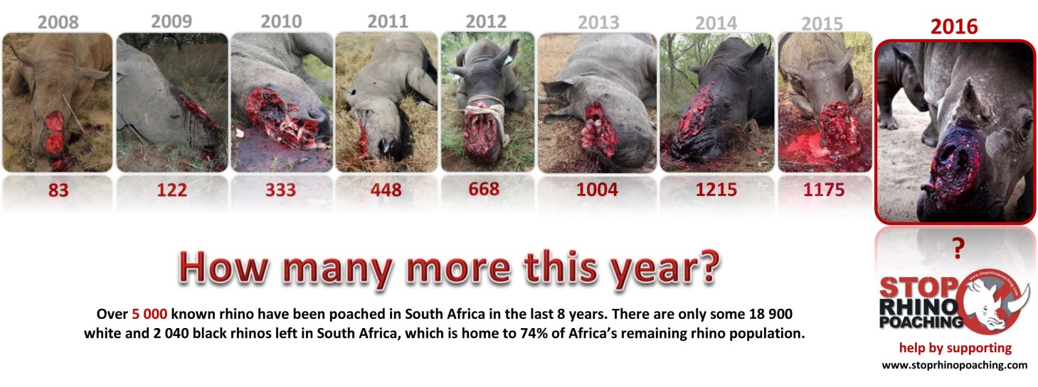 The British Army Special Armed Services (SAS) is now training a private army in Kenya to protect the species from poachers; a sergeant was asked by the BBC what he would do if he spotted one of his friends or neighbours up to no good. His reply is unequivocal. "If he comes to kill rhinos he is robbing the entire community. And I will shoot him dead."
See http://www.bbc.com/news/magazine-35503077
What are your views?
For those of you who have already donated towards the ‘Save our Rhinos’ initiative, thank you. For those who are still considering making a donation, however small, please see the banking details on the second page of the calendar. The Amdec Group will match every donation made.
Thank you for your support to the rhino crisis.
Regards
John Wilson
Chairman, The Amdec Group

